**SQL ASSIGNMENT SET 2**

**Q51) Write an SQL query to report the name, population, and area of the big countries. Return the result table in any order. The query result format is in the following example.**

Sol) At first , create an empty table and then insert records in it using multi insert command.

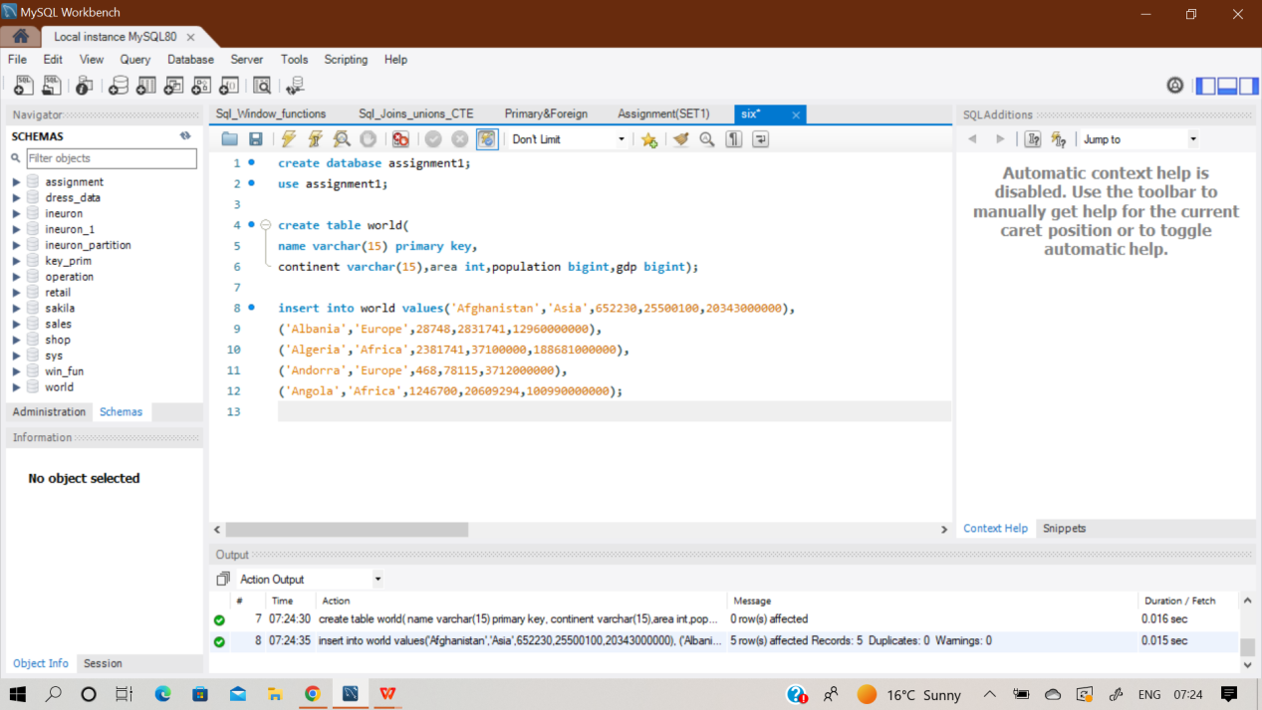

**select name,population,area from world**

**where area>=3000000 or population >= 25000000;**

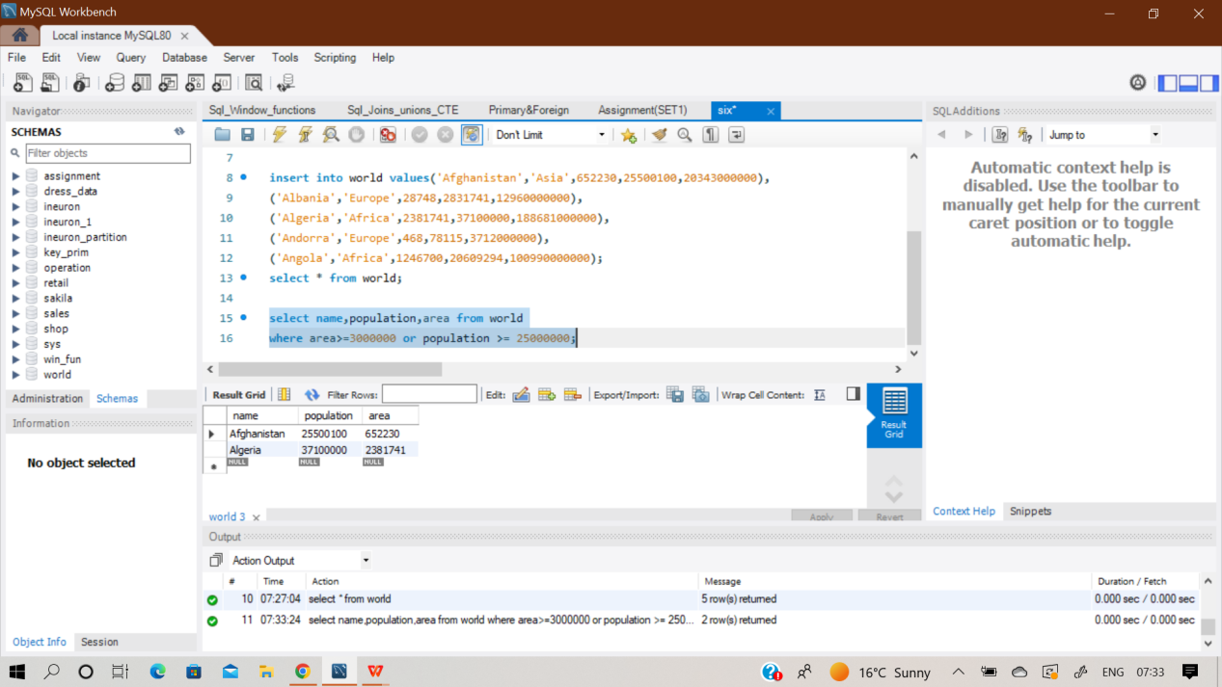

**Q52) Write an SQL query to report the names of the customer that are not referred by the customer with id = 2. Return the result table in any order. The query result format is in the following example.**

**Sol)** At first , create an empty table named ‘Customer’ and then insert records in it using multi insert command.

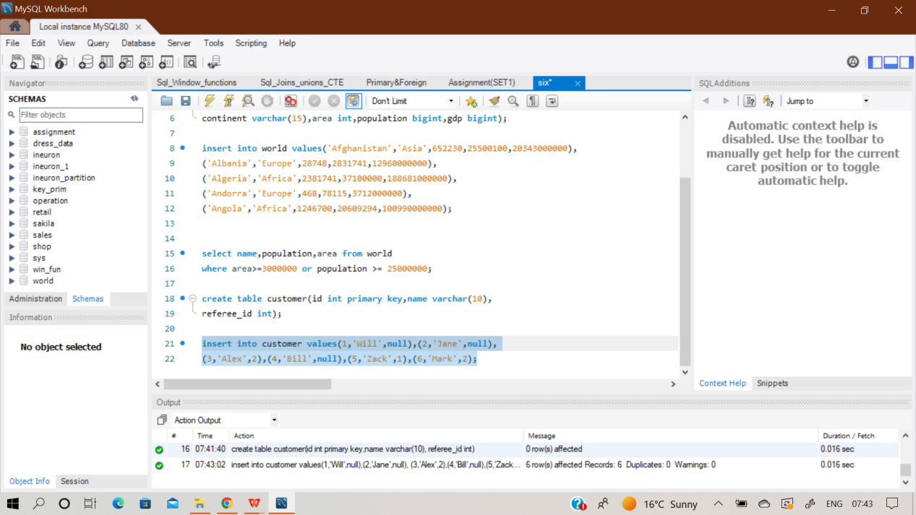

**select name from customer where referee_id <> 2**

**or referee_id is null;**

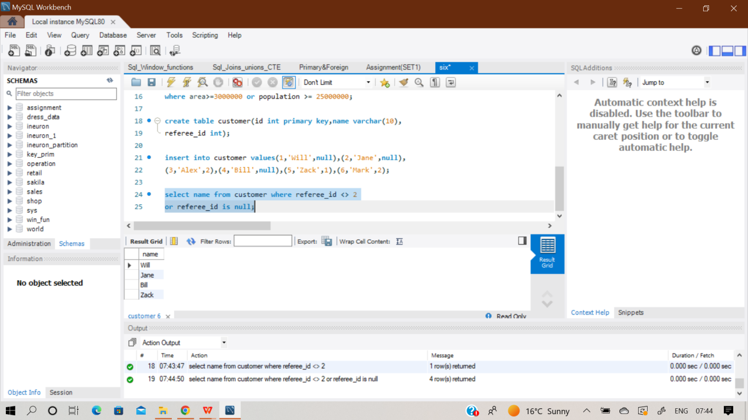

**Q53) Write an SQL query to report all customers who never order anything. Return the result table in any order. The query result format is in the following example.**

**Sol)** At first , create two empty table named ‘Customers’ and ‘Orders’ And then insert records in it using multi insert command.

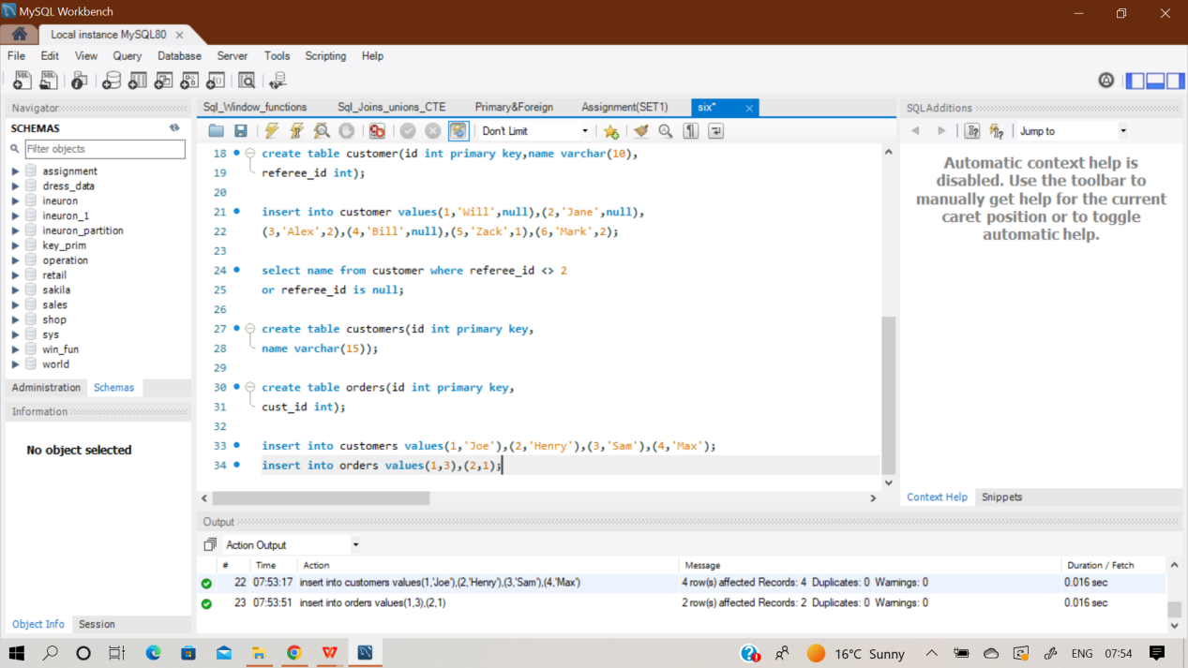

**select name from customers where id not in**

**(select cust_id from orders);**

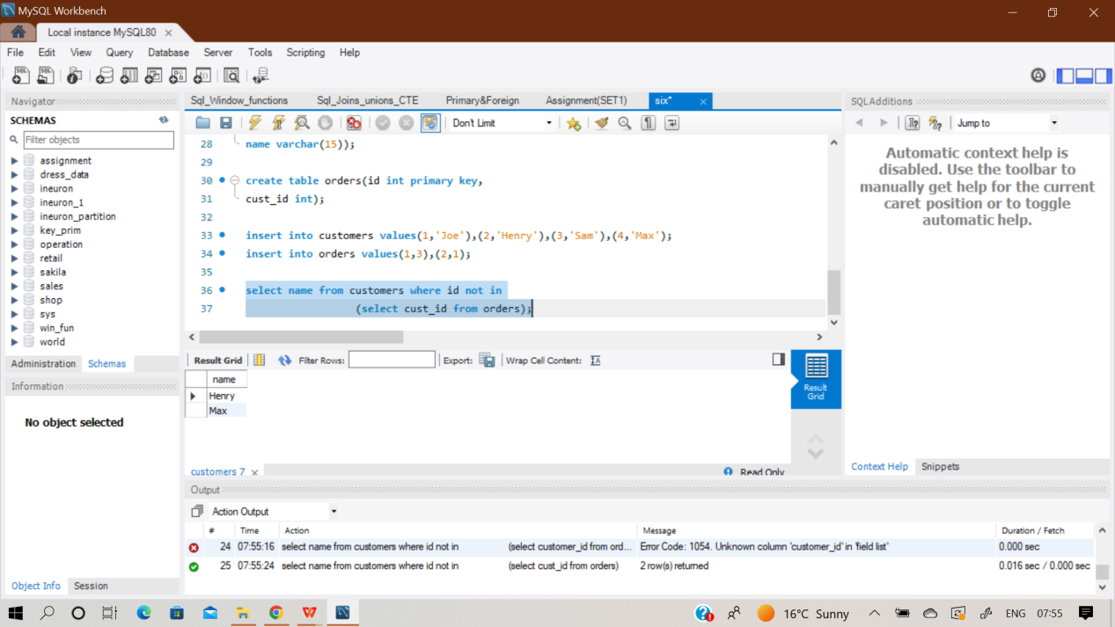

**Q54) Write an SQL query to find the team size of each of the employees. Return result table in any order. The query result format is in the following example.**

**Sol)** At first , create an empty table named ‘Employee’. And then insert records in it using multi insert command.

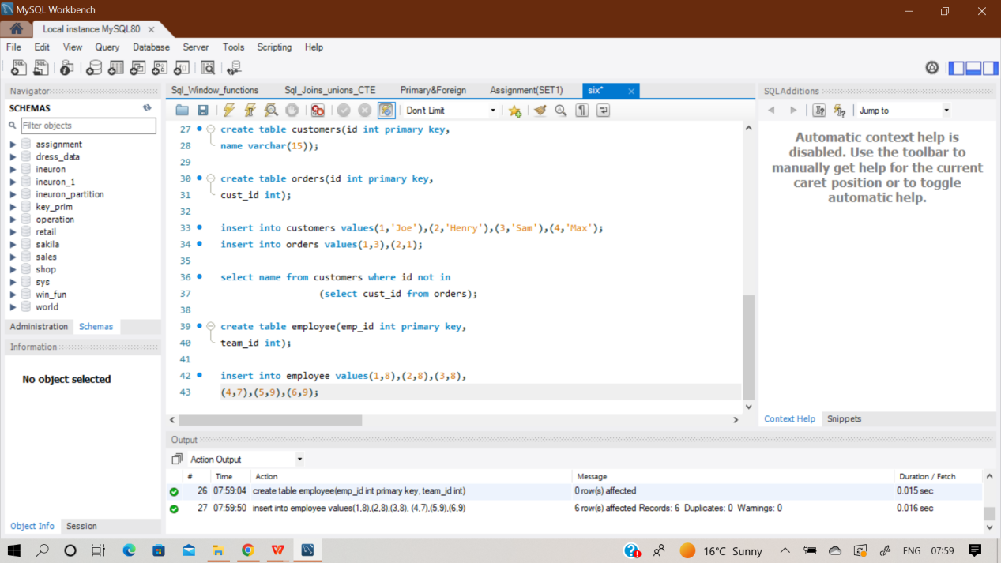

**select emp_id,**

**count(team_id) over(partition by team_id) as team_size**

**from employee;**

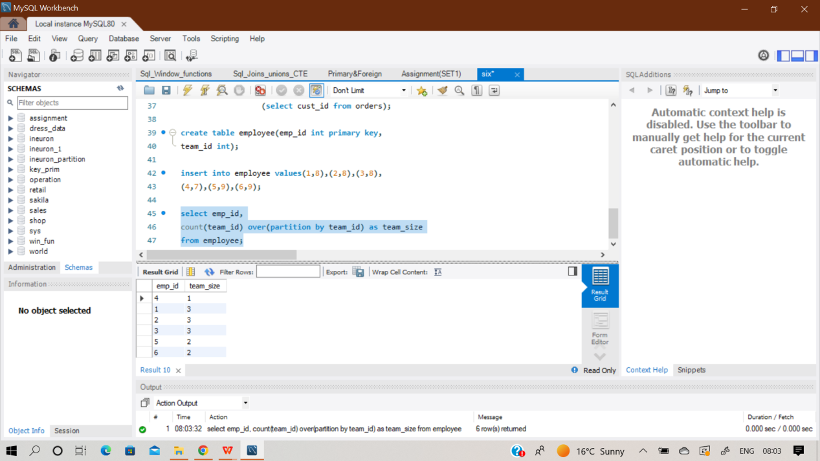

**Q55) Write an SQL query to find the countries where this company can invest. Return the result table in any order. The query result format is in the following example**

**Sol)** At first , create 3 empty table naming ‘Person’,’Country’ & ‘Calls’. And then insert records in it using multi insert command.

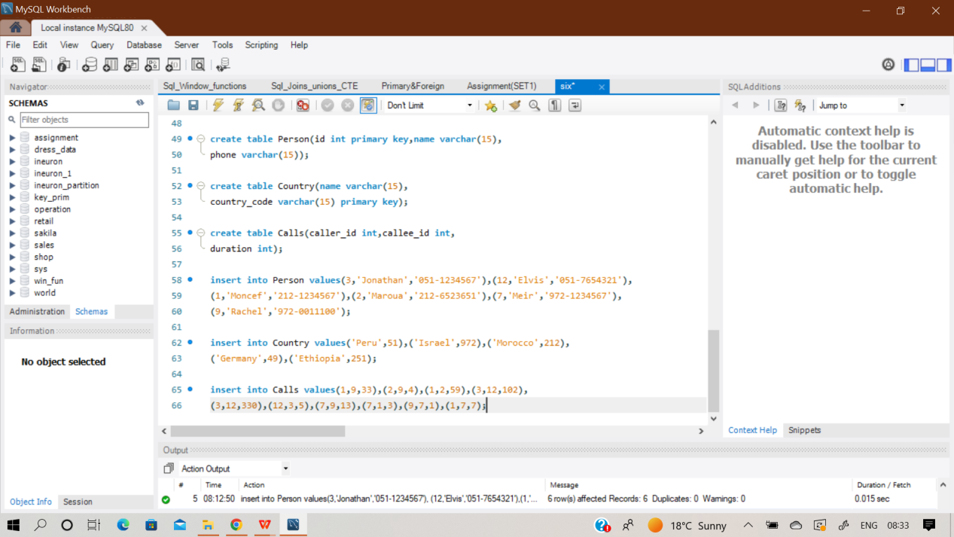

**with phn as(select caller_id as id,duration from calls**

**union all**

**select callee_id as id,duration from calls)**

**select c.name as country from phn**

**join person p on phn.id = p.id**

**join country c on left(p.phone,3) = c.country_code**

**group by c.name**

**having avg(duration)>(select avg(duration) from Calls);**

**Q56) Write an SQL query to report the device that is first logged in for each player. Return the result table in any order. The query result format is in the following example.**

**Sol)** At first , create an empty table named ‘Activity’ and then insert records in it using multi insert command.

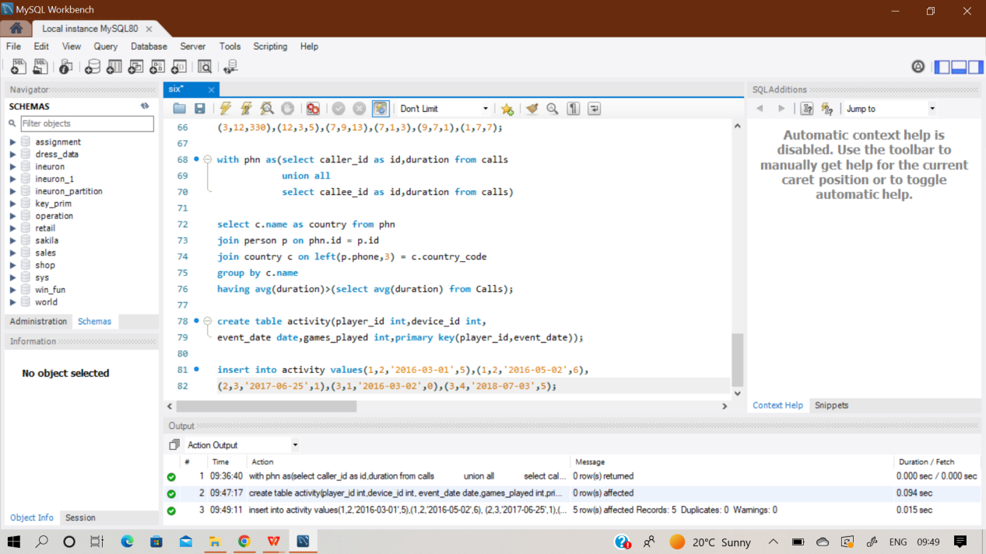

**select distinct(player_id),**

**first_value(device_id)over(partition by player_id order by event_date asc) as device_id**

**from activity;**

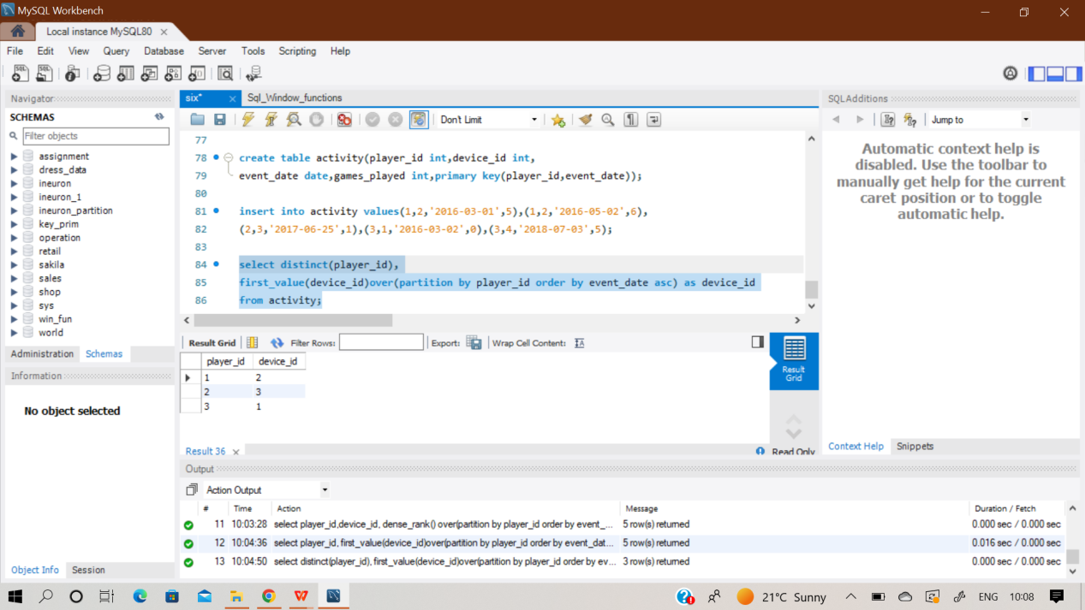

**Q57) Write an SQL query to find the customer_number for the customer who has placed the largest number of orders. The test cases are generated so that exactly one customer will have placed more orders than any other customer. The query result format is in the following example.**

**Sol)** At first , create an empty table named ‘Orders’ and then insert records in it using multi insert command.

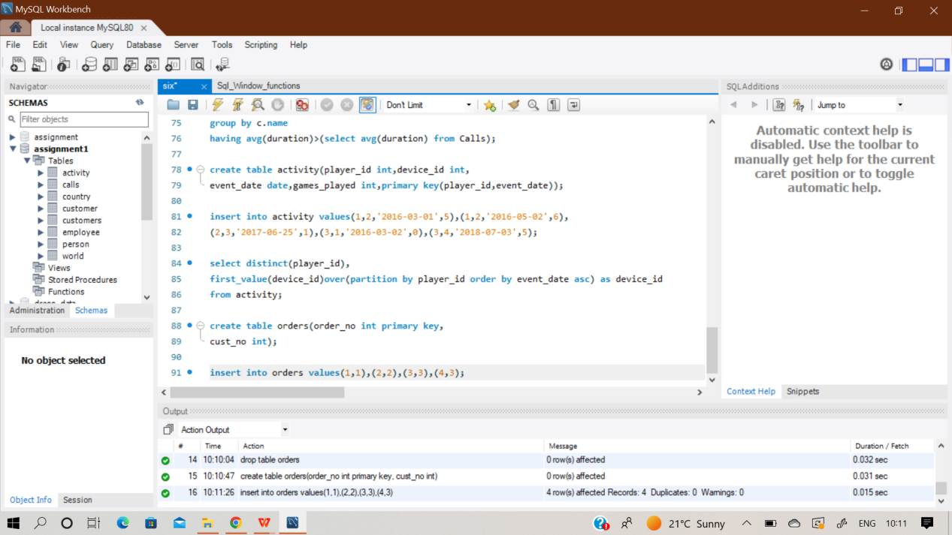

After inserting records, now the table can be used to perform desired query over it.

**select cust_no from orders**

**group by cust_no**

**order by count(*) desc limit 1;**

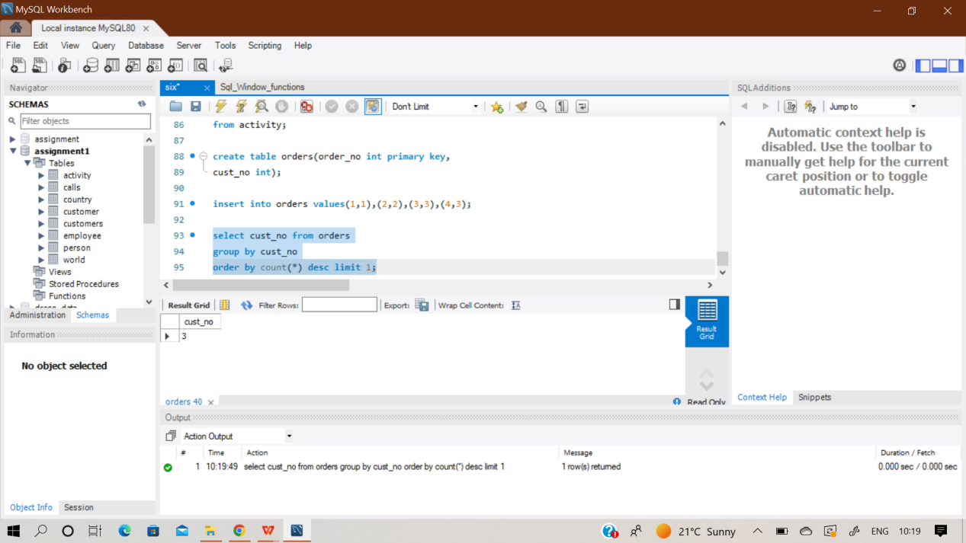

**Q58) Write an SQL query to report all the consecutive available seats in the cinema. Return the result table ordered by seat_id in ascending order. The test cases are generated so that more than two seats are consecutively available. The query result format is in the following example.**

**Sol)** At first , create an empty table named ‘Cinema’ and then insert records in it using multi insert command.

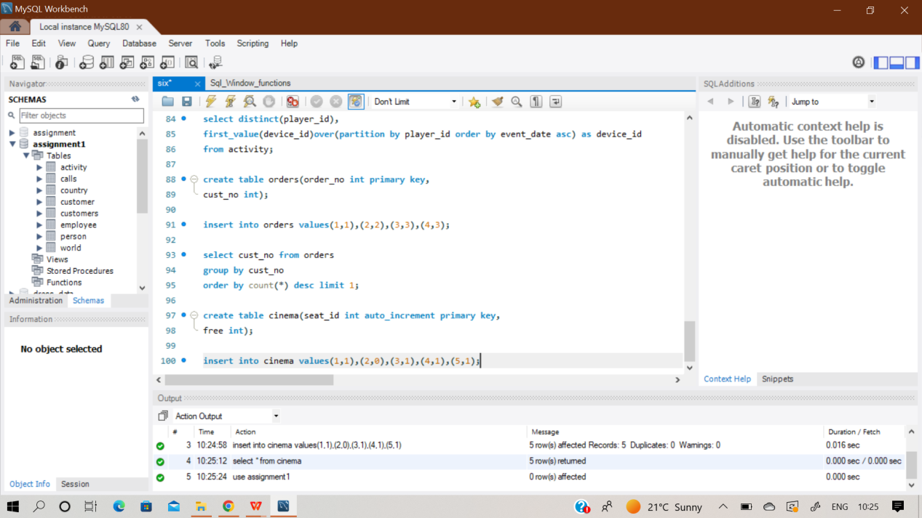

**select seat_id from cinema where free = 1 and**

**(seat_id+1 in (select seat_id from cinema where free = 1)**

**or seat_id-1 in (select seat_id from cinema where free = 1));**

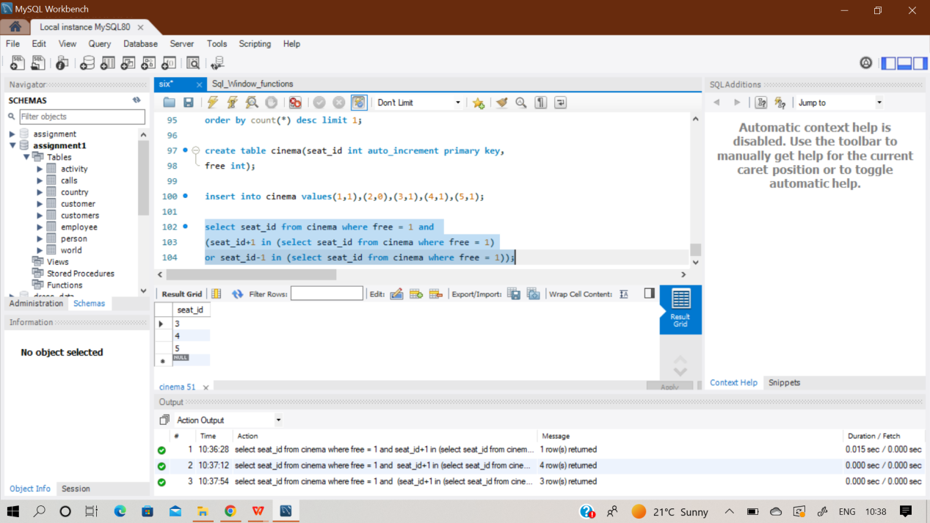

**Q59) Write an SQL query to report the names of all the salespersons who did not have any orders related to the company with the name "RED". Return the result table in any order.The query result format is in the following example.**

**Sol)** At first , create 3 empty table named ‘Salesperson’, ‘Company’ & ‘Orders’ and then insert records in it using multi insert command.

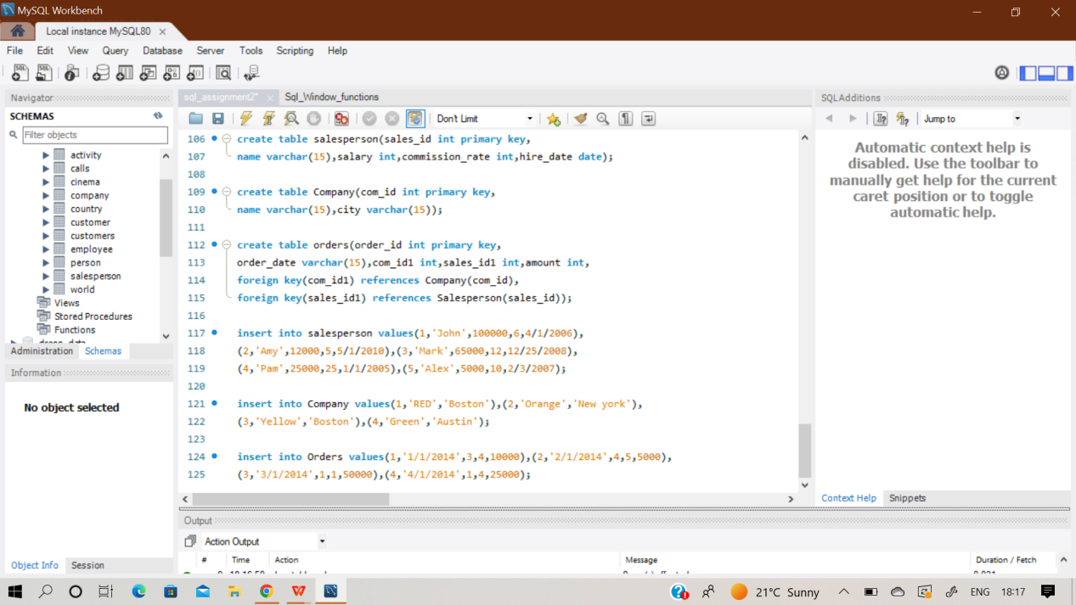

**Select s.name from salesperson s**

**where s.sales_id not in(**

**select sales_id1 from orders o**

**inner join company c**

**on o.com_id1 = c.com_id**

**where o.com_id1 in**

**(select c.com_id from company c where c.name= 'RED'));**

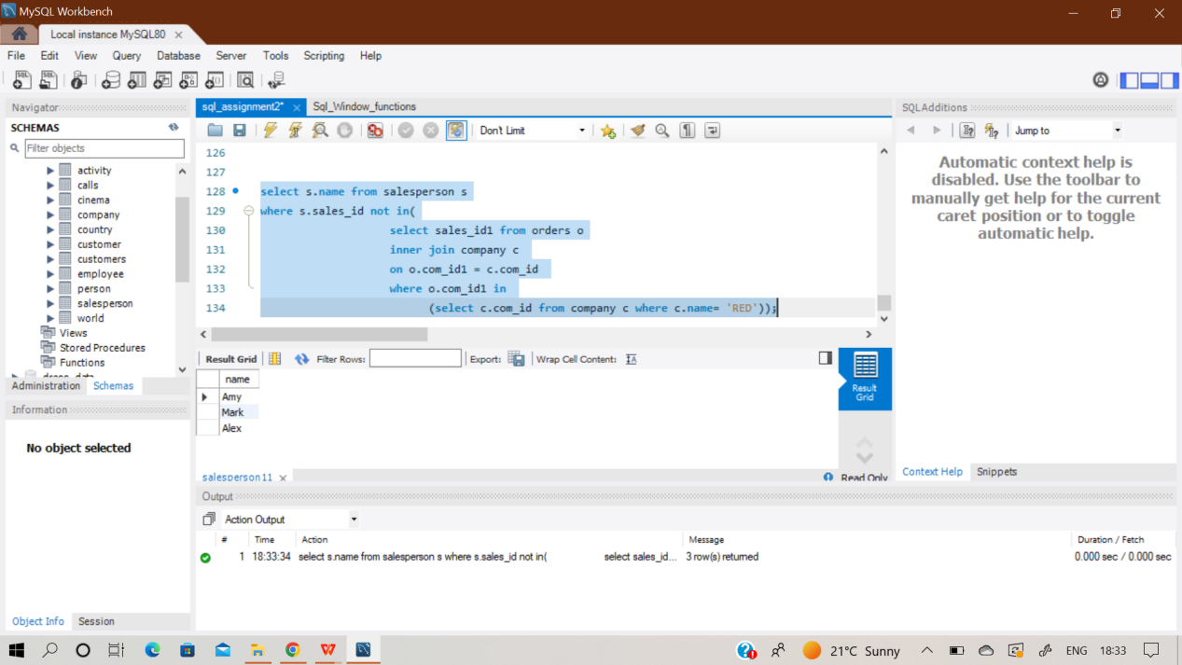

**Q60) Write an SQL query to report for every three line segments whether they can form a triangle. Return the result table in any order. The query result format is in the following example**

**Sol)** At first , create an empty table named ‘Triangle’ and then insert records in it using multi insert command.

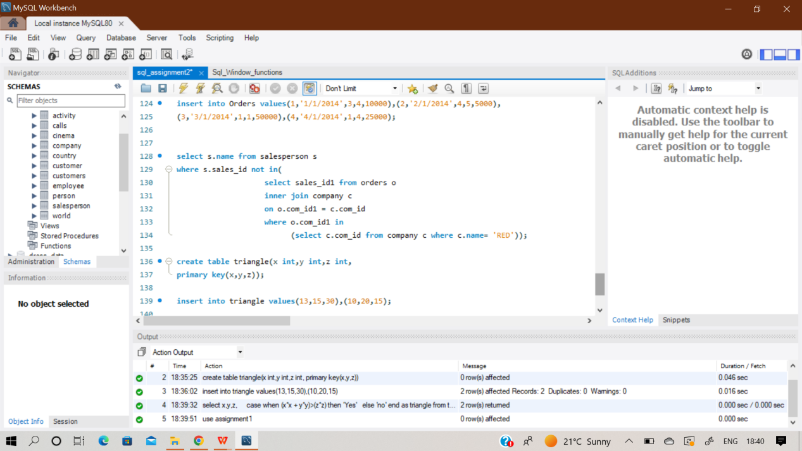

**Given dimensions can be checked whether it will form a triangle or not using simple theorem of a^2 + b^2 > c^2.**

**select x,y,z,**

**case when (x*x + y*y)>(z*z) then 'Yes'**

**else 'no'**

**end as triangle**

**from triangle;**

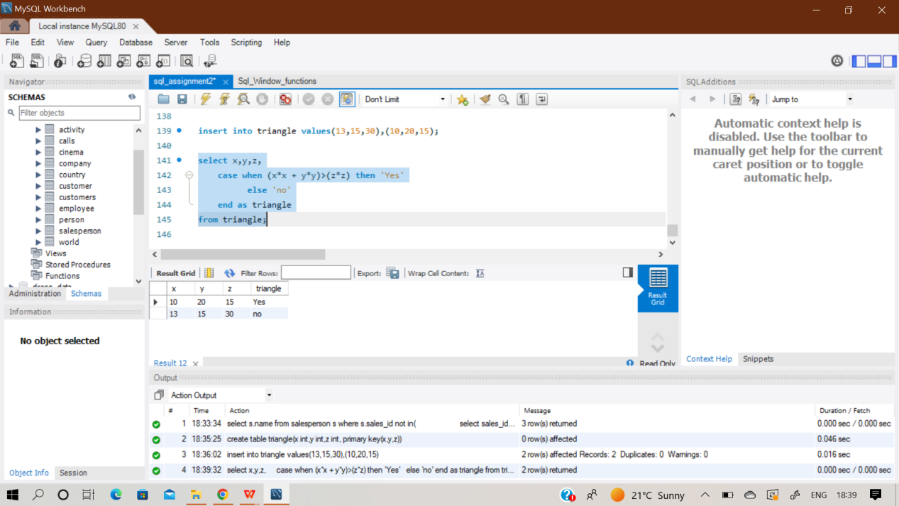

**Q61) Write an SQL query to report the shortest distance between any two points from the Point table. The query result format is in the following example.**

**Sol)** At first , create an empty table named ‘Point’ and then insert records in it using multi insert command.

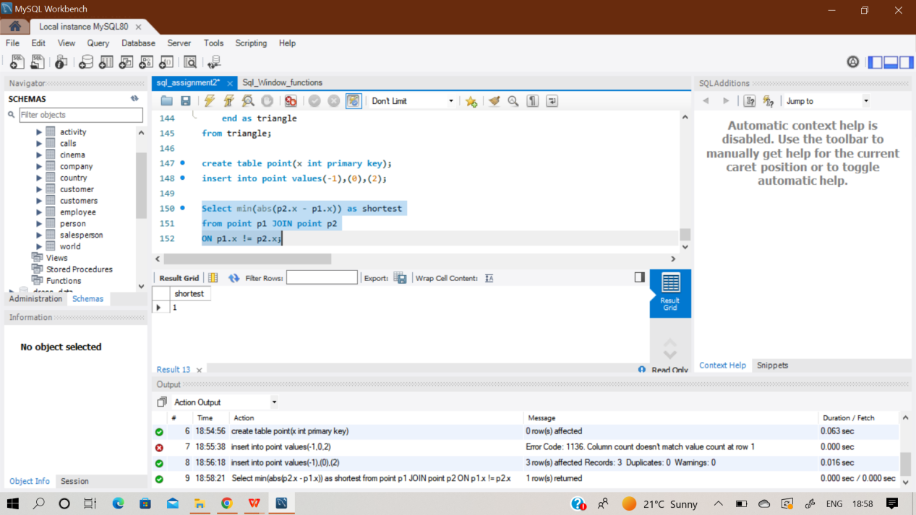

**Select min(abs(p2.x - p1.x)) as shortest**

**from point p1 JOIN point p2**

**ON p1.x != p2.x;**

**Q62) Write a SQL query for a report that provides the pairs (actor_id, director_id) where the actor has cooperated with the director at least three times. Return the result table in any order.**

**The query result format is in the following example.**

**Sol)** At first , create an empty table named ‘ActorDirector’ and then insert records in it using multi insert command.

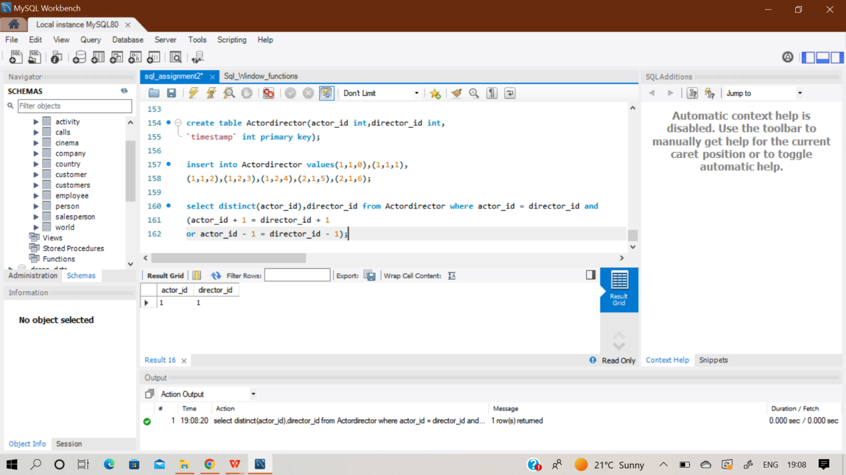

**select distinct(actor_id),director_id from Actordirector where actor_id = director_id and**

**(actor_id + 1 = director_id + 1**

**or actor_id - 1 = director_id - 1);**

**Q63) Write an SQL query that reports the product_name, year, and price for each sale_id in the Sales table. Return the resulting table in any order. The query result format is in the following example.**

**Sol)** At first , create 2 empty tables named ‘Sales’ & ‘Product’ and then insert records in it using multi insert command.

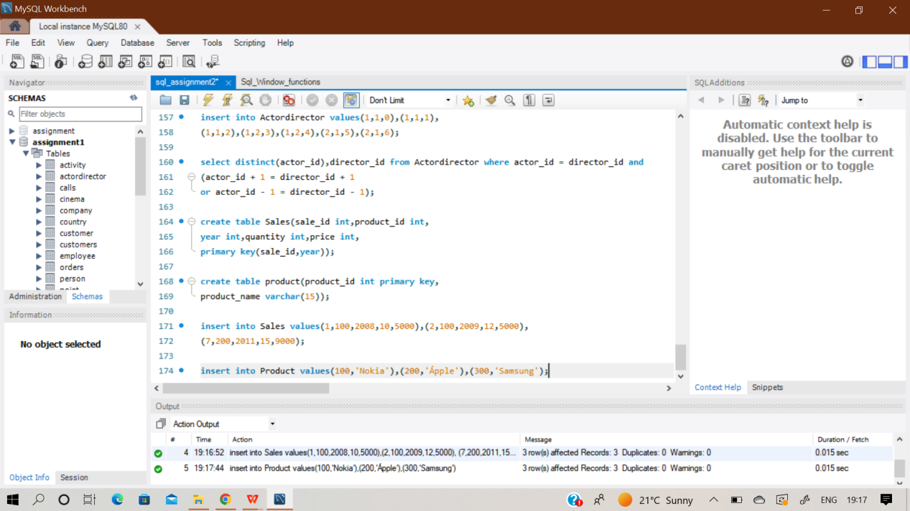

**select p.product_name,s.year,s.price**

**from product p right join sales s**

**on p.product_id = s.product_id;**

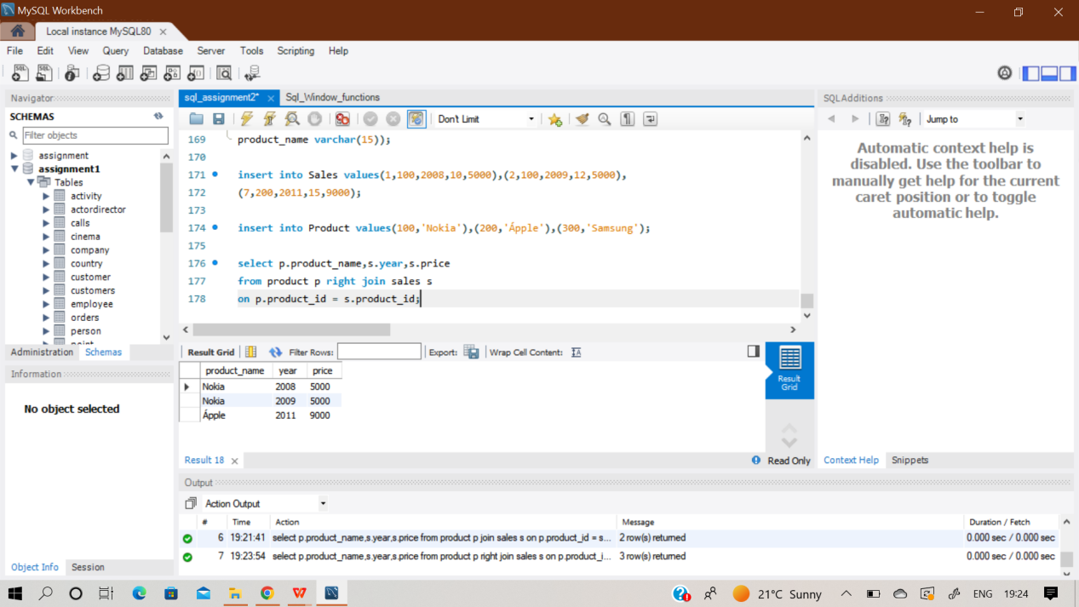

**Q64) Write an SQL query that reports the average experience years of all the employees for each project, rounded to 2 digits. Return the result table in any order. The query result format is in the following example.**

**Sol)** At first , create 2 empty tables named ‘Project’ & ‘Employee’ and then insert records in it using multi insert command.

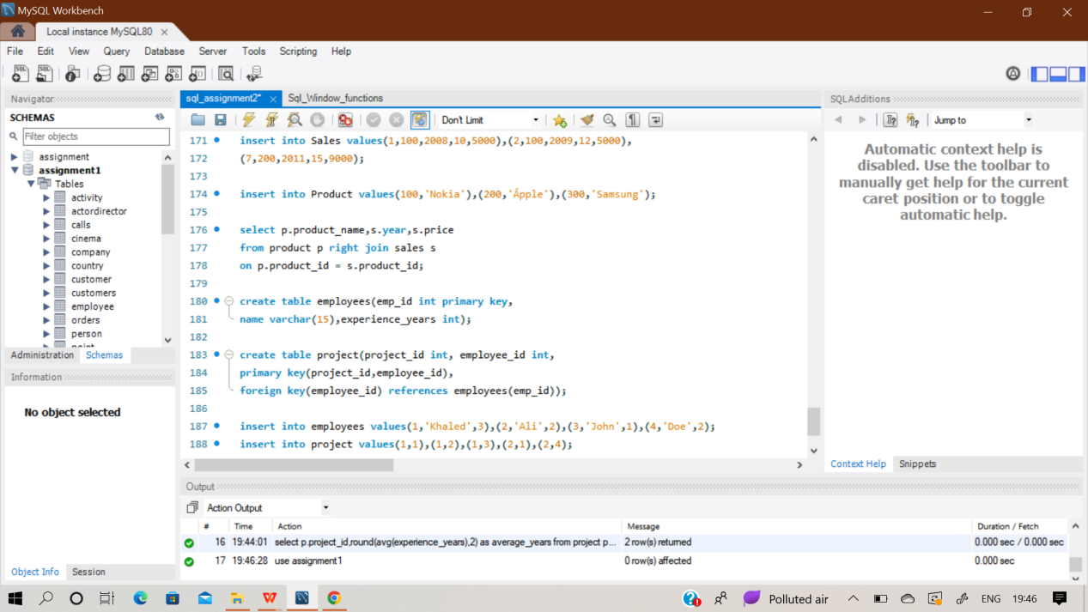

**select p.project_id,round(avg(experience_years),2) as average_years**

**from project p inner join employees e**

**on p.employee_id = e.emp_id**

**group by p.project_id;**

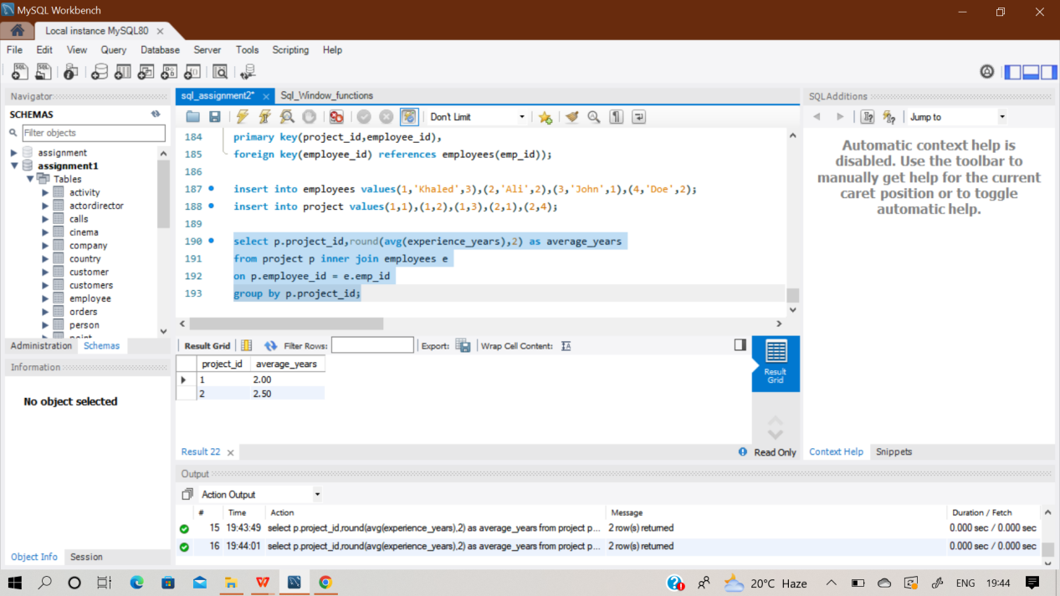

**Q65) Write an SQL query that reports the best seller by total sales price, If there is a tie, report them all. Return the result table in any order. The query result format is in the following example.**

**Sol)** At first , create 2 empty tables named ‘Sales’ & ‘produkt’ and then insert records in it using multi insert command.

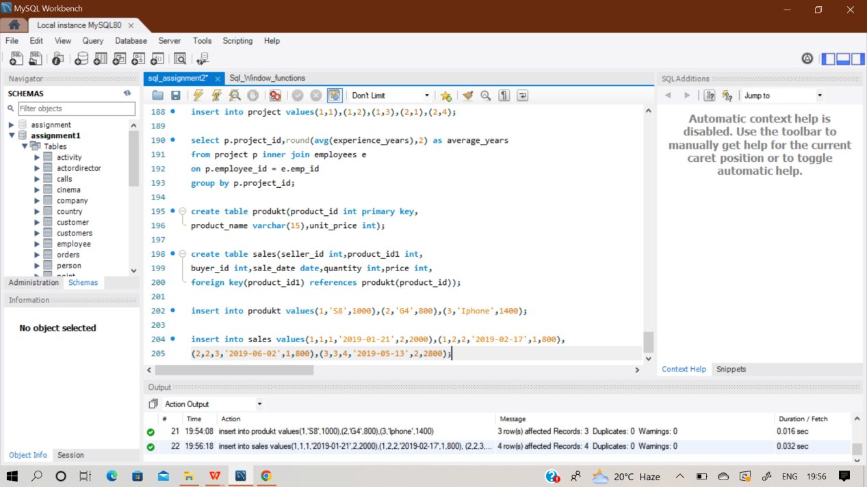

**select distinct(seller_id)**

**from sales**

**group by seller_id**

**having sum(price) = (select sum(price) as sum**

**from sales**

**group by seller_id**

**order by sum desc limit 1);**

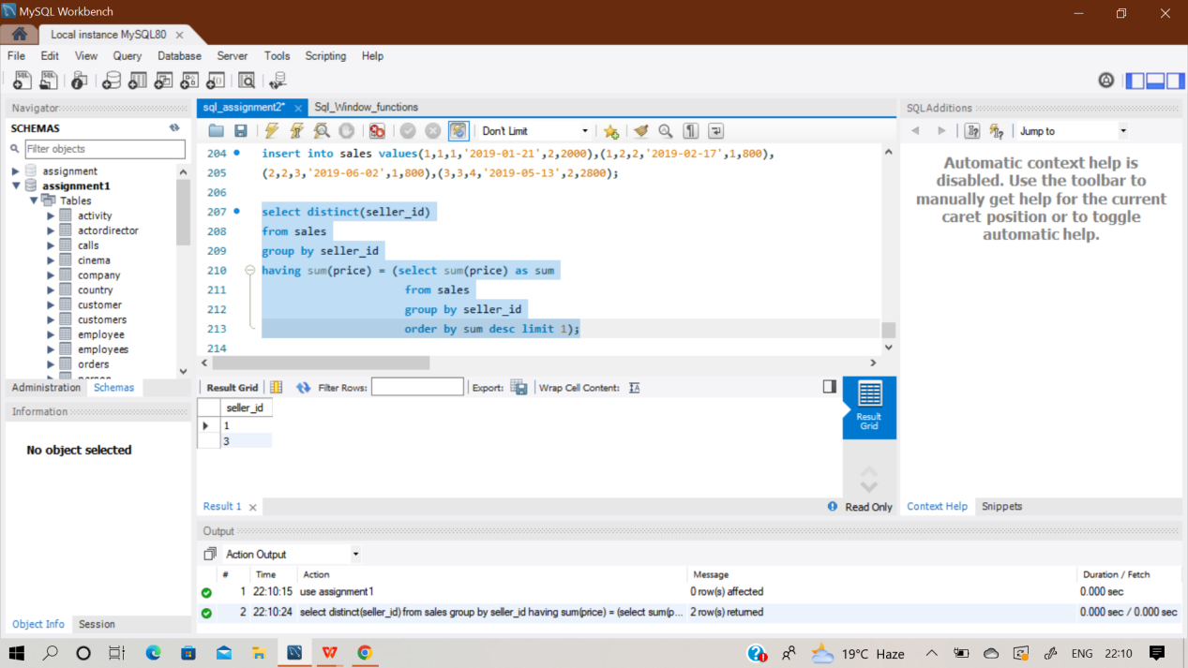

**Q66) Write an SQL query that reports the buyers who have bought S8 but not iPhone. Note that S8 and iPhone are products present in the Product table. Return the result table in any order. The query result format is in the following example.**

**Sol)** In this question the two tables used are already created earlier in the last question naming ‘produkt ’ & ‘Sales’. Hence there is only need of query analysis on both tables.

**select buyer_id from sales s**

**where product_id1 in (select product_id from produkt p**

**where product_name = 'S8' and product_name <> 'iphone');**

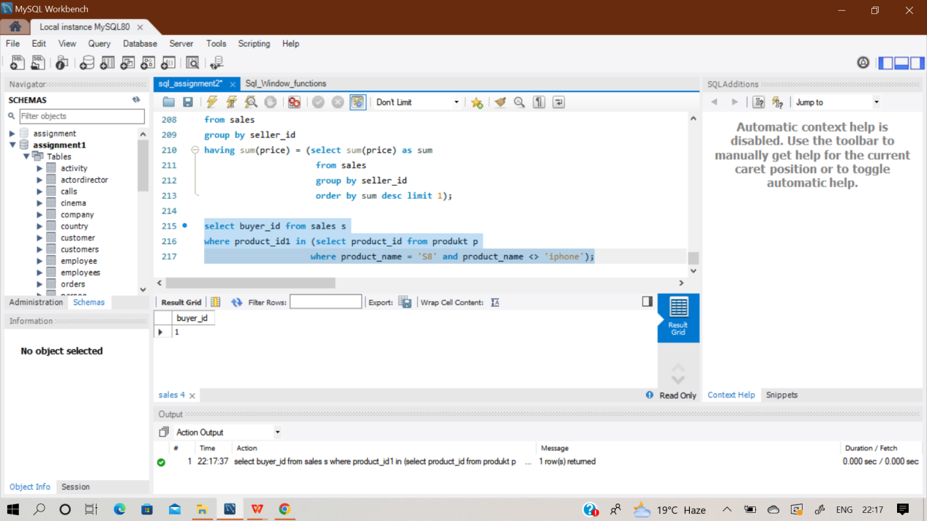

**Q67) Write an SQL query to compute the moving average of how much the customer paid in a seven days window (i.e., current day + 6 days before). average_amount should be rounded to two decimal places. Return result table ordered by visited_on in ascending order.**

**The query result format is in the following example.**

**Sol)** At first , create an empty table named ‘Cust’ and then insert records in it using multi insert command.

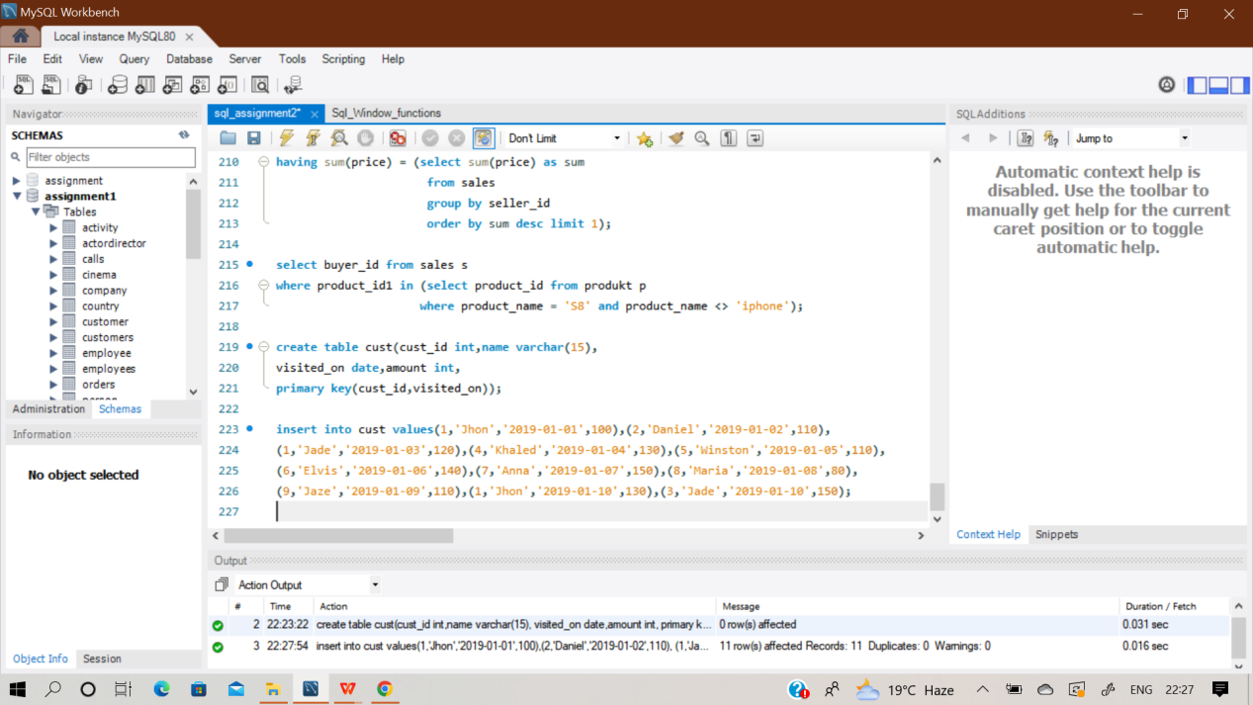

**select c1.visited_on, sum(c2.amount) as amount,**

**round(avg(c2.amount), 2) as average_amount**

**from (select visited_on, sum(amount) as amount**

**from cust group by visited_on) c1**

**join (select visited_on, sum(amount) as amount**

**from cust group by visited_on) c2**

**on datediff(c1.visited_on, c2.visited_on) between 0 and 6**

**group by c1.visited_on**

**having count(c2.amount) = 7;**

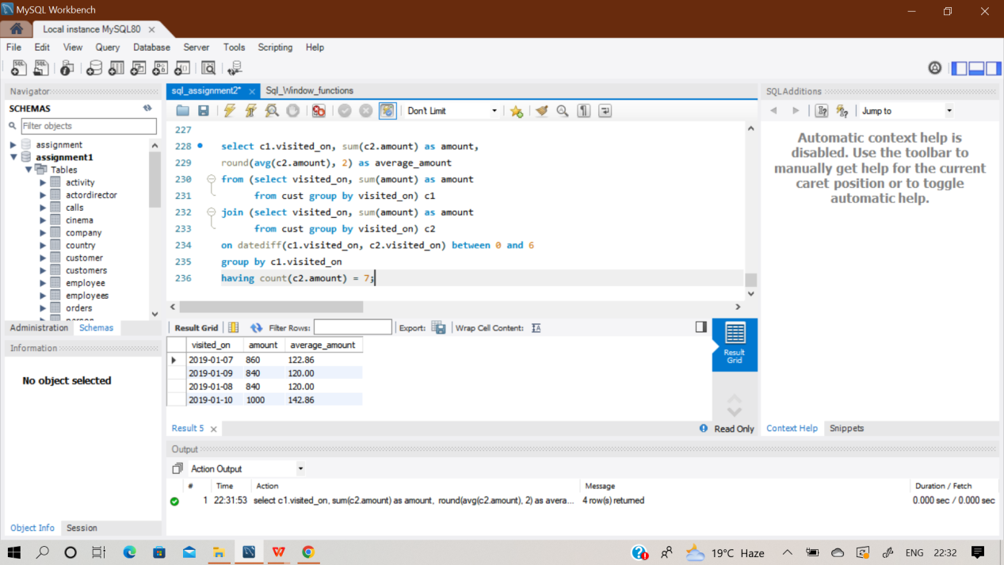

**Q68) Write an SQL query to find the total score for each gender on each day. Return the result table ordered by gender and day in ascending order. The query result format is in the following example.**

**Sol)** At first , create an empty table named ‘Scores’ and then insert records in it using multi insert command.

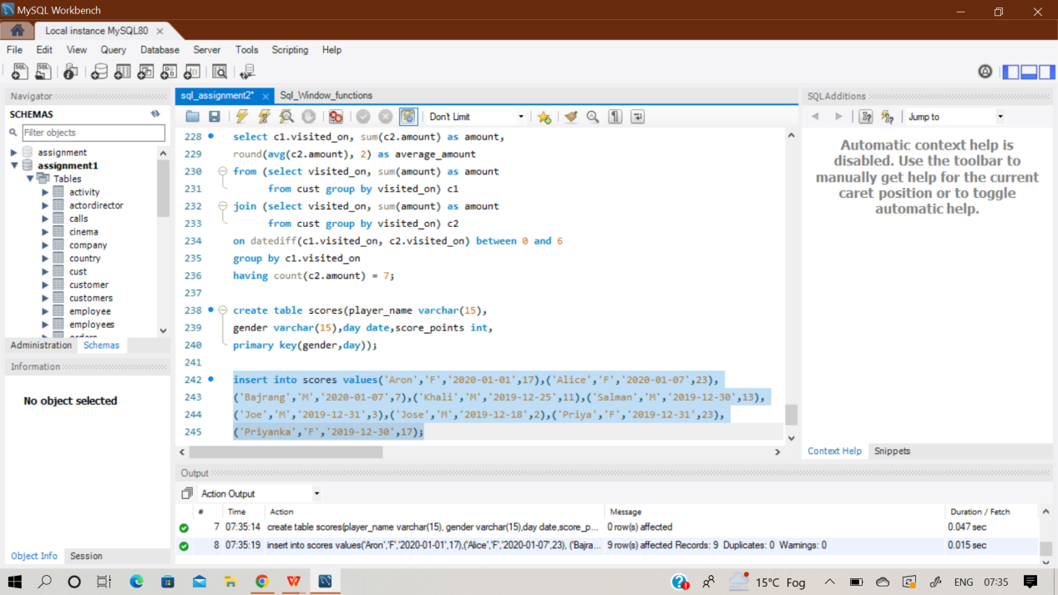

**Select gender,day,**

**Sum(score_points) over(partition by gender order by day) as 'total'**

**from scores**

**order by gender asc;**

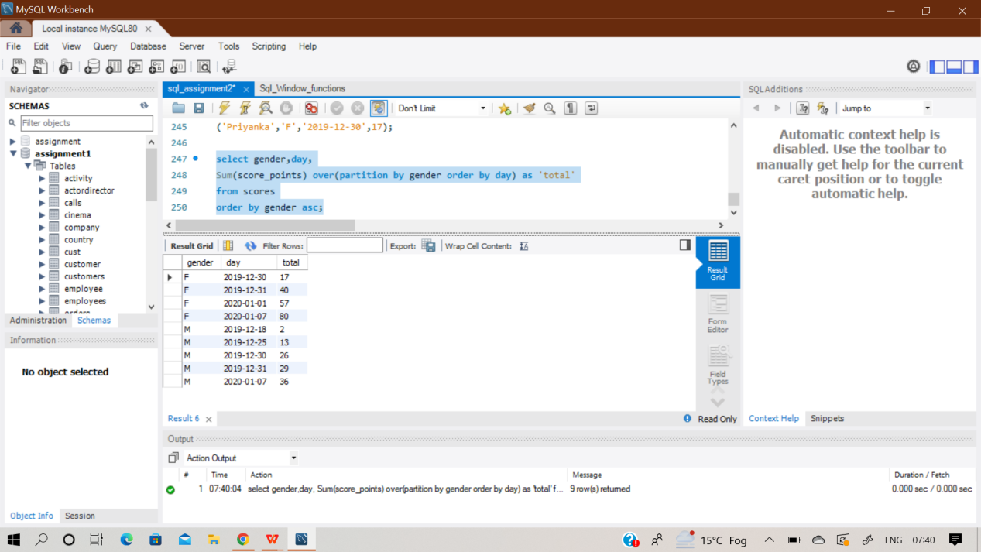

**Q69) Write an SQL query to find the start and end number of continuous ranges in the table Logs. Return the result table ordered by start_id. The query result format is in the following example.**

**Sol)** At first , create an empty table named ‘Logs’ and then insert records in it using multi insert command.

**select min(log_id) as start_id, max(log_id) as end_id**

**from (select *, row_number() over (order by log_id) as row_num from logs**

**) as a**

**group by (log_id - row_num)**

**order by min(log_id);**

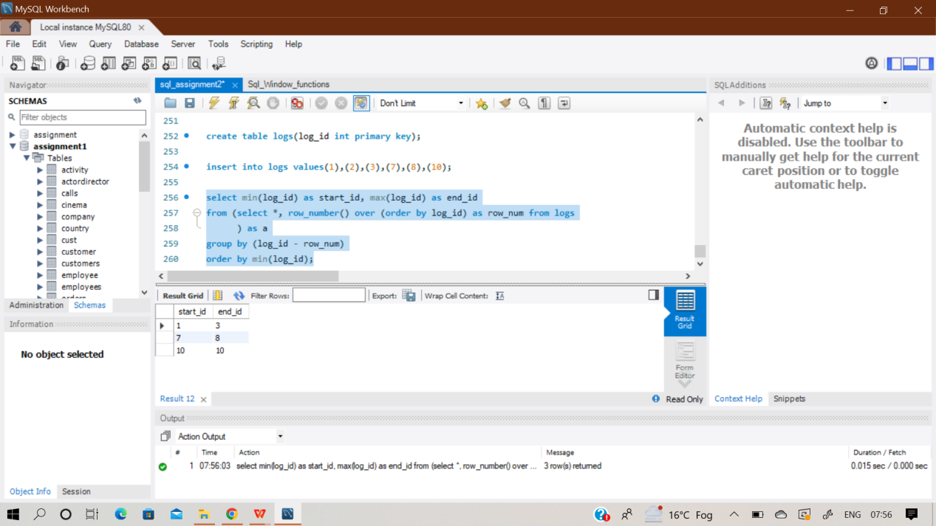

**Q70) Write an SQL query to find the number of times each student attended each exam. Return the result table ordered by student_id and subject_name. The query result format is in the following example.**

**Sol)** At first , create 3 empty table named ‘Students’,’Subjects’ & ‘Exams’ and then insert records in it using multi insert command.

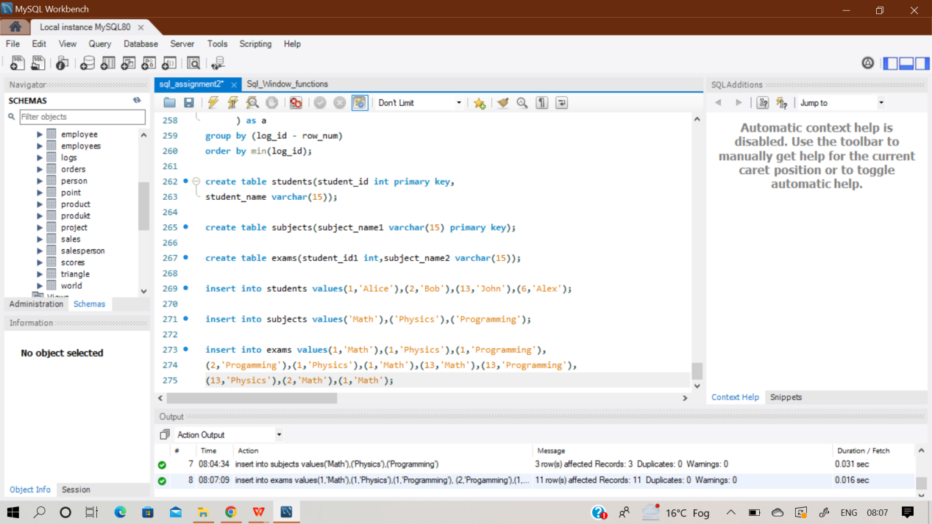

**select a.student_id,a.student_name,b.subject_name1,count(c.student_id1) as 'attended_exams'**

**from students a inner join subjects b**

**left join exams c**

**on a.student_id = c.student_id1 and b.subject_name1 = c.subject_name2**

**group by a.student_id,b.subject_name1;**

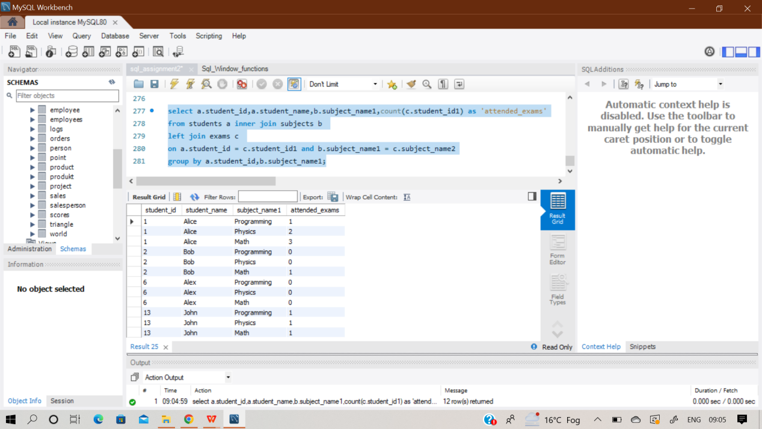

**Q71) Write an SQL query to find employee_id of all employees that directly or indirectly report their work to the head of the company.**

**The indirect relation between managers will not exceed three managers as the company is small. Return the result table in any order. The query result format is in the following example.**

**Sol)** At first , create an empty table named ‘Employees’ and then insert records in it using multi insert command.

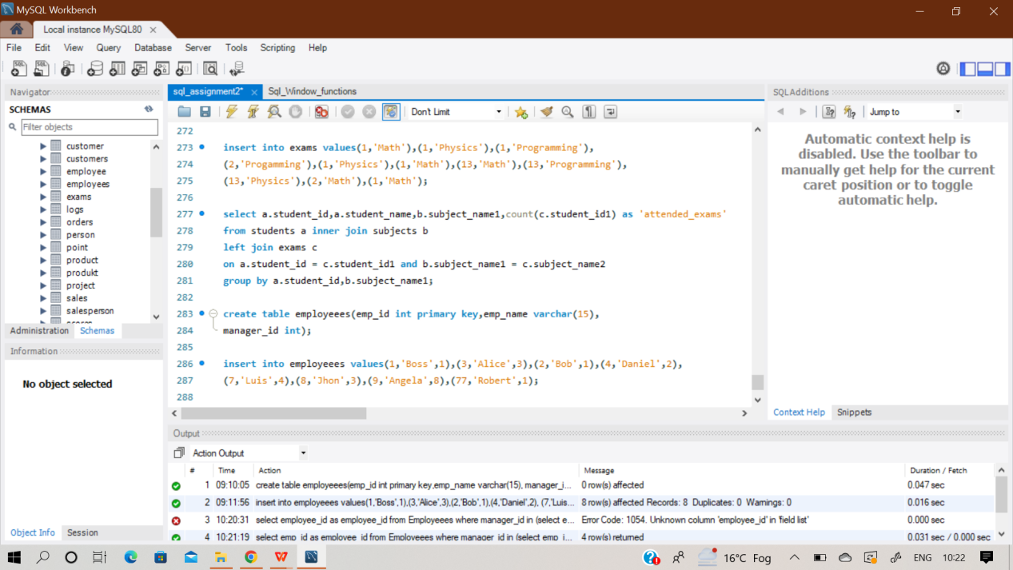

**select emp_id as employee_id**

**from Employeees where manager_id in**

**(select emp_id from Employeees where manager_id in**

**(select emp_id from Employeees where manager_id =1))**

**and emp_id <>1;**

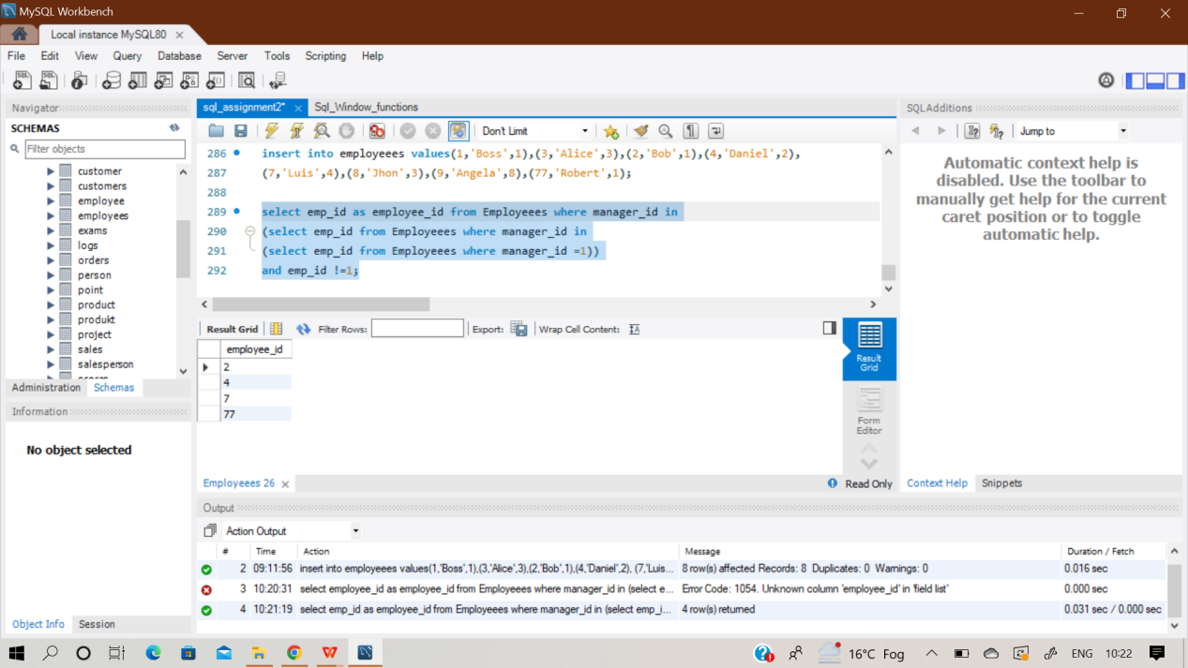

**Q72) Write an SQL query to find for each month and country, the number of transactions and their total amount, the number of approved transactions and their total amount. Return the result table in any order. The query result format is in the following example.**

**Sol)** At first , create an empty table named ‘Transactions’ and then insert records in it using multi insert command.

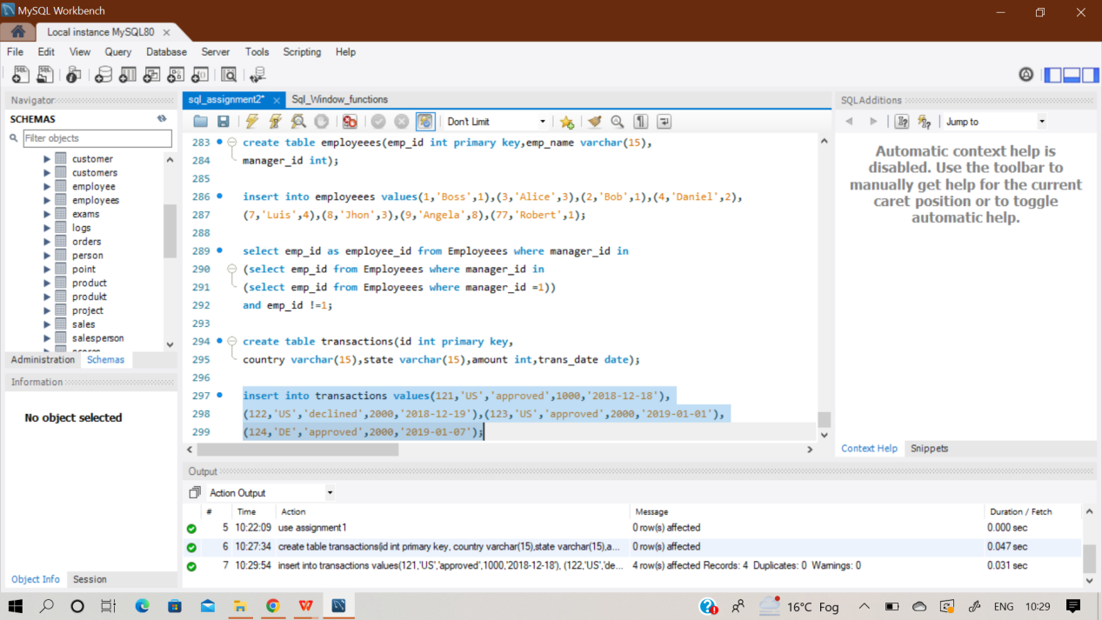

**select date_format(trans_date,"%y-%m") as month,country,**

**count(id) as trans_count,**

**sum(case when state='approved' then 1 else 0 end) as 'approved_count',**

**sum(amount) as trans_total_amount,**

**sum(case when state='approved' then amount else 0 end) as 'approved_total_amount'**

**from transactions**

**group by month,country;**

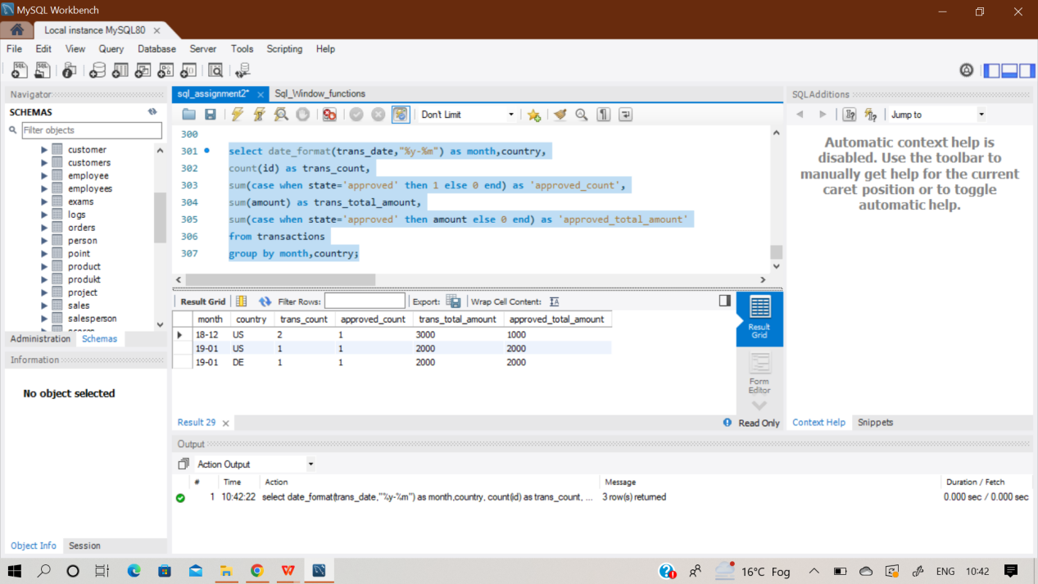

**Q73) Write an SQL query to find the average daily percentage of posts that got removed after being reported as spam, rounded to 2 decimal places. The query result format is in the following example.**

**Sol)** At first , create an empty table named ‘Actions’ and then insert records in it using multi insert command.

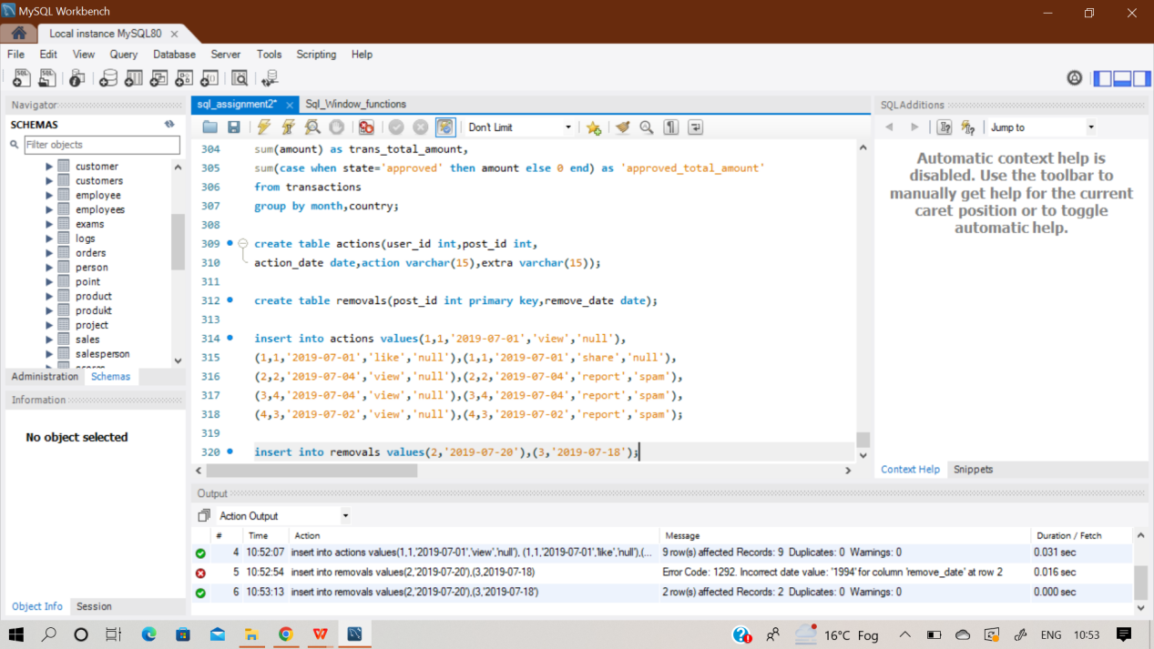

**select round(avg(daily),2)**

**as ‘average_daily_percent’ from**

**(select count(distinct(r.post_id))/count(distinct a.post_id)*100 as 'daily'**

**from actions a left join removals r**

**on a.post_id = r.post_id**

**where a.extra = 'spam'**

**group by action_date) as t;**

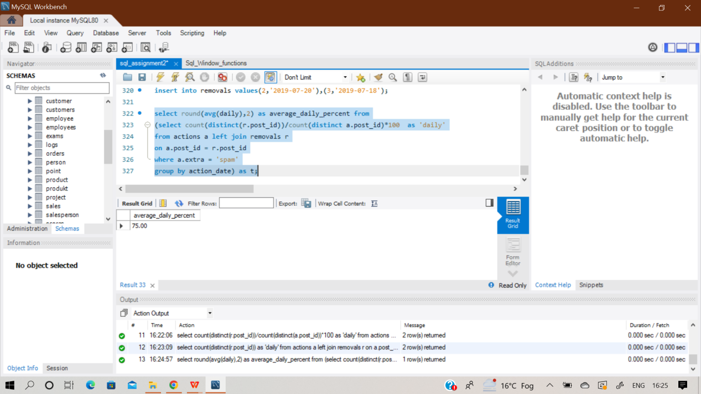

**Q74,75) SAME QUESTION AS Q43**

**Q76) Write an SQL query to find the salaries of the employees after applying taxes. Round the salary to the nearest integer.**

**The tax rate is calculated for each company based on the following criteria:**

**● 0% If the max salary of any employee in the company is less than $1000.**

**● 24% If the max salary of any employee in the company is in the range [1000, 10000] inclusive.**

**● 49% If the max salary of any employee in the company is greater than $10000**

**Sol)** At first , create an empty table named ‘salaries’ and then insert records in it using multi insert command.

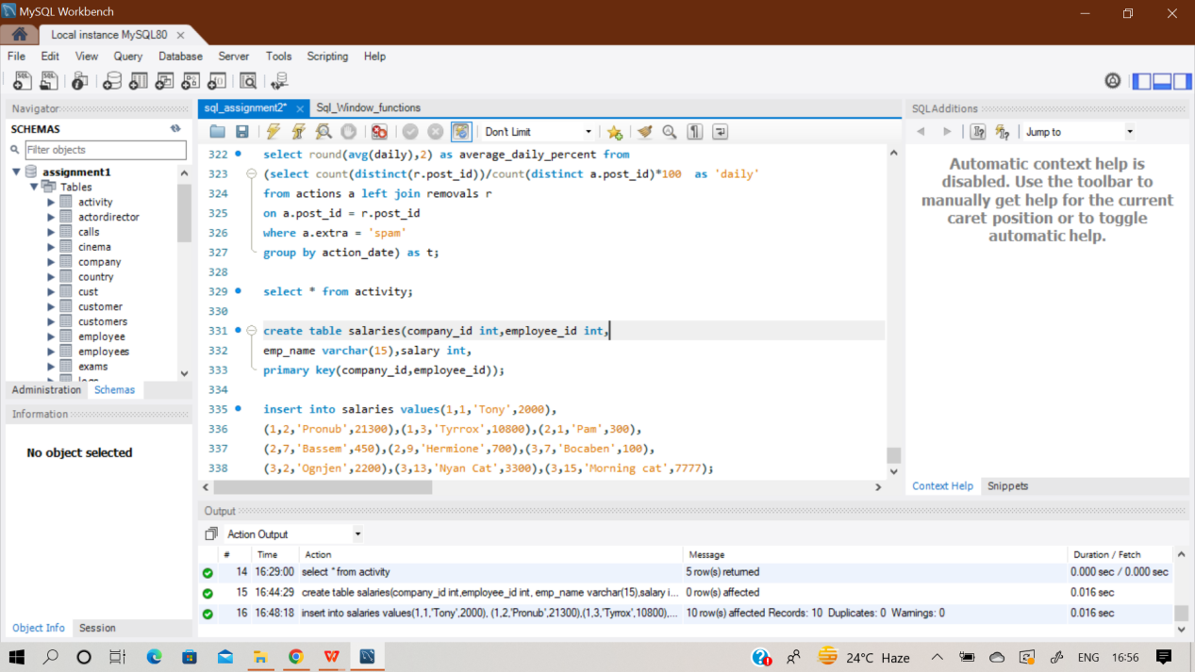

**with cte as(**

**select company_id,**

**(case when max(salary) < 1000 then 1.0**

**when max(salary) <= 10000 then 0.76**

**else 0.51**

**end) as tax**

**from salaries**

**group by company_id)**

**select s.company_id, s.employee_id, s.emp_name, ROUND(s.salary * t.tax) as salary**

**from Salaries s join cte t on s.company_id = t.company_id;**

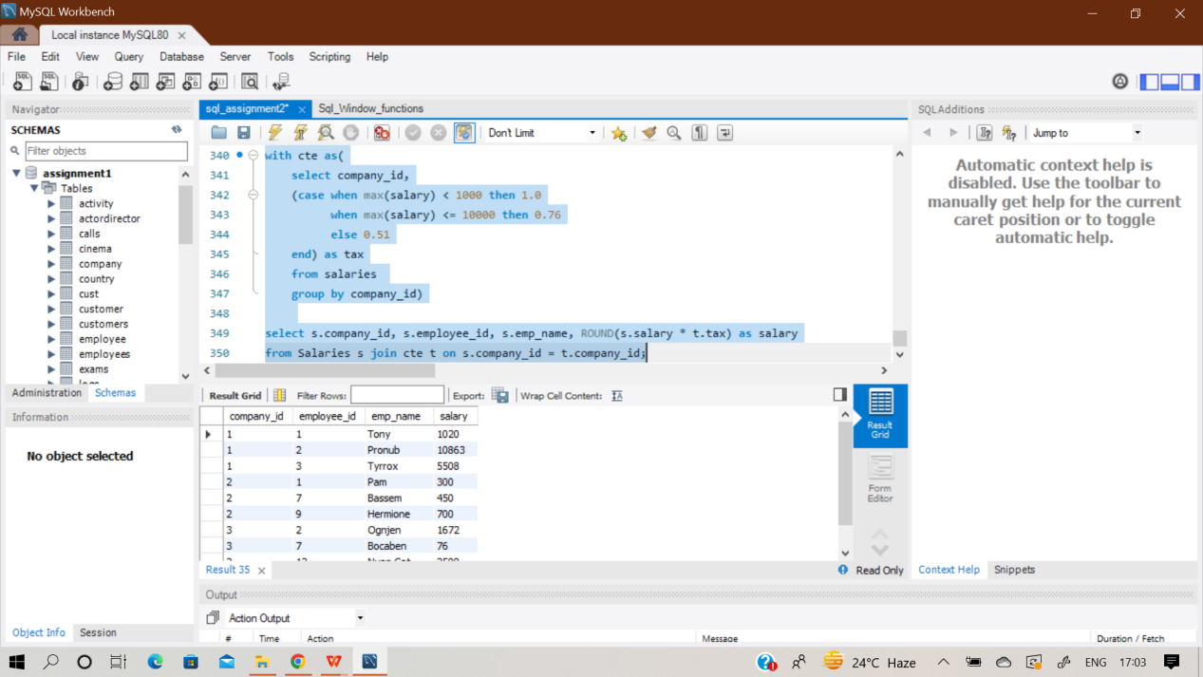

**Q77) Write an SQL query to report the difference between the number of apples and oranges sold each day. Return the result table ordered by sale_date. The query result format is in the following example.**

**Sol)** At first , create an empty table named ‘sales’ and then insert records in it using multi insert command.

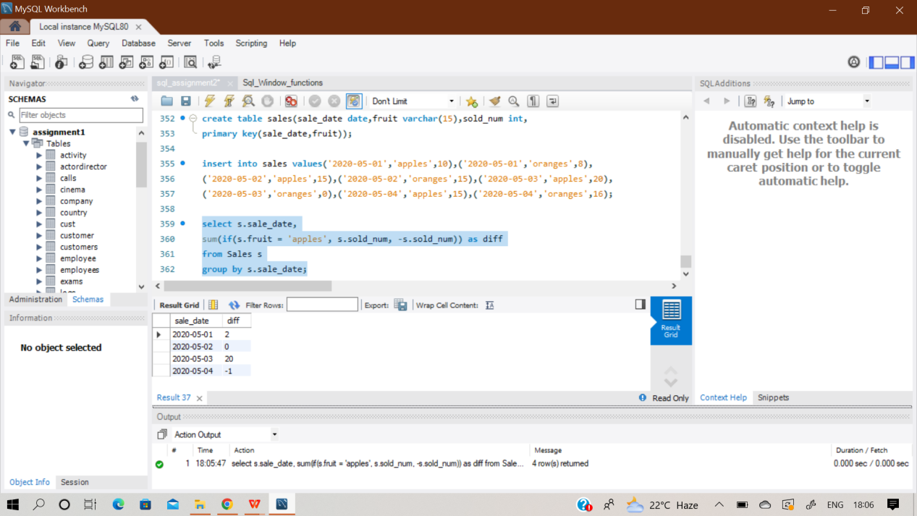

**select s.sale_date,**

**sum(if(s.fruit = 'apples', s.sold_num, -s.sold_num)) as diff**

**from Sales s**

**group by s.sale_date;**

**Q78) Write an SQL query to evaluate the boolean expressions in Expressions table. Return the result table in any order. The query result format is in the following example.**

**Sol)** At first , create two empty table named ‘variables’ & ‘Expressions’ and then insert records in it using multi insert command.

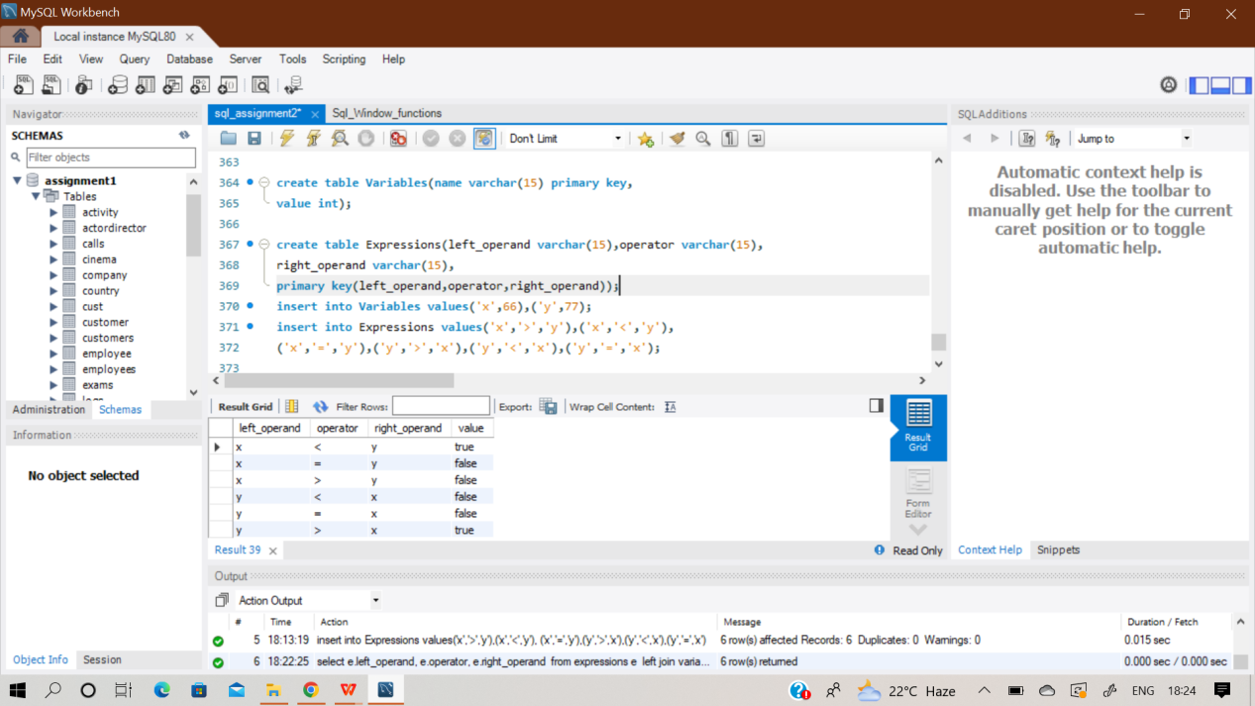

**select e.left_operand, e.operator, e.right_operand,**

**(case**

**when e.operator = '<' then if(l.value < r.value,'true','false')**

**when e.operator = '>' then if(l.value > r.value,'true','false')**

**else if(l.value = r.value,'true','false')**

**end) as value**

**from expressions e**

**left join variables l on e.left_operand = l.name**

**left join variables r on e.right_operand = r.name;**

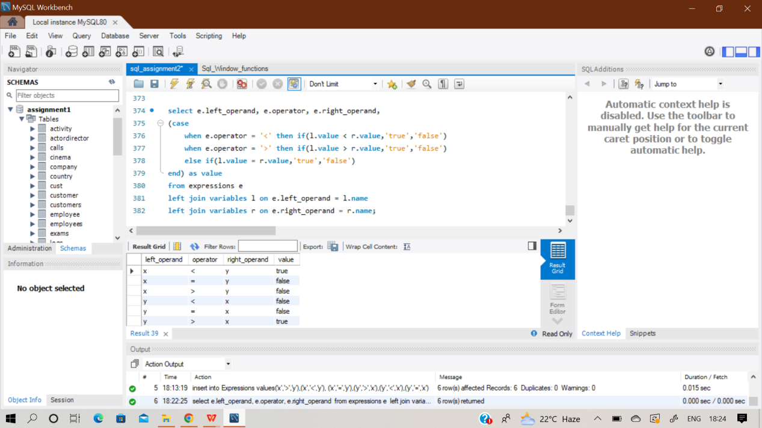

**Q79) SAME QUESTION AS Q35**

**Q80) SAME QUESTION AS Q55**

**Q81) Query the Name of any student in STUDENTS who scored higher than 75 Marks. Order your output by the last three characters of each name. If two or more students both have names ending in the same last three characters (i.e.: Bobby, Robby, etc.), secondary sort them by ascending ID.**

**Sol)** At first , create an empty table named ‘student’ and then insert values in it.

**select name from student**

**where marks>75**

**order by SUBSTR(Name, -3), id asc;**

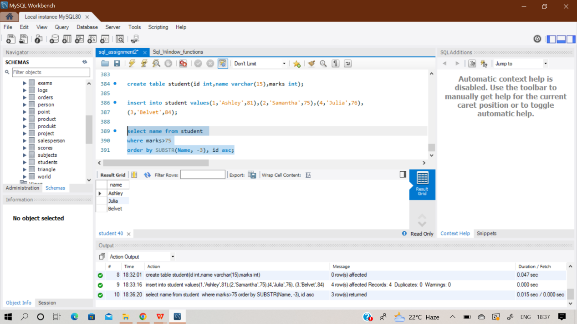

**Q82) Write a query that prints a list of employee names (i.e.: the name attribute) from the Employee table in alphabetical order.**

**Sol)** At first , create an empty table named ‘emp’ and then insert values in it.

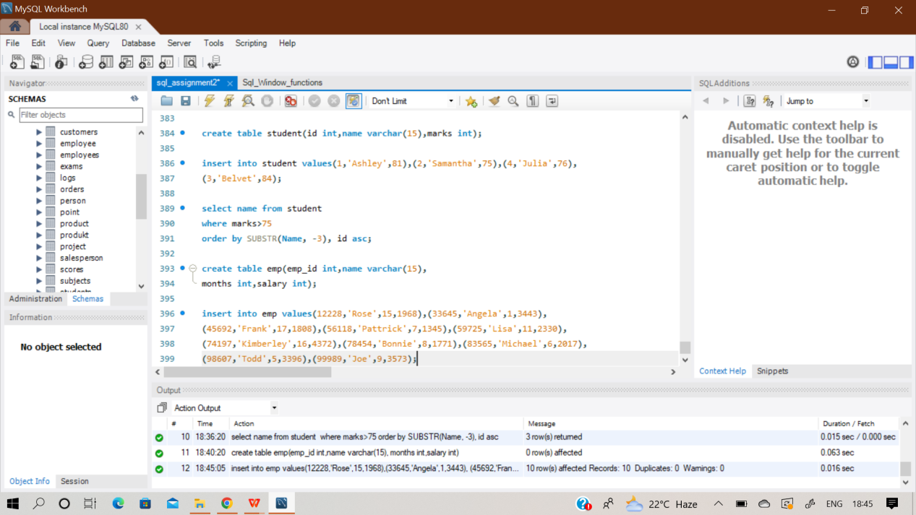

**select name from emp**

**order by name asc;**

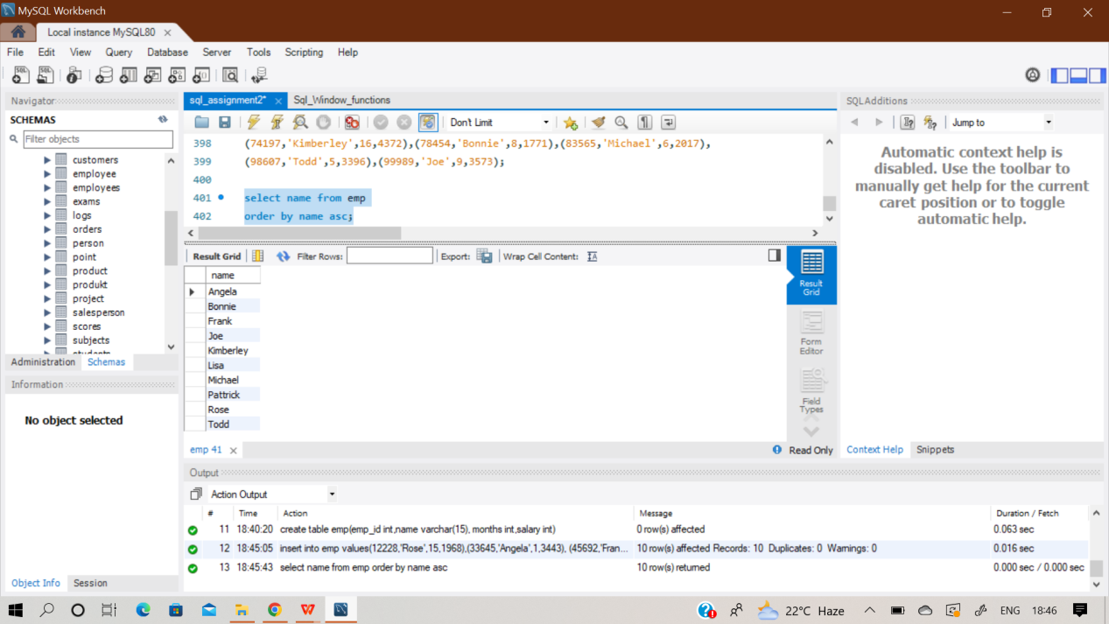

**Q83) Write a query that prints a list of employee names (i.e.: the name attribute) for employees in Employee having a salary greater than $2000 per month who have been employees for less than 10**

**months. Sort your result by ascending employee_id.**

**Sol)** The same table is used as in the previous question. In this question we have to find out names having salary greater than 2000 dollars with work experience less than 10 months.

**select name from emp**

**where salary > 2000 and months < 10**

**order by emp_id asc;**

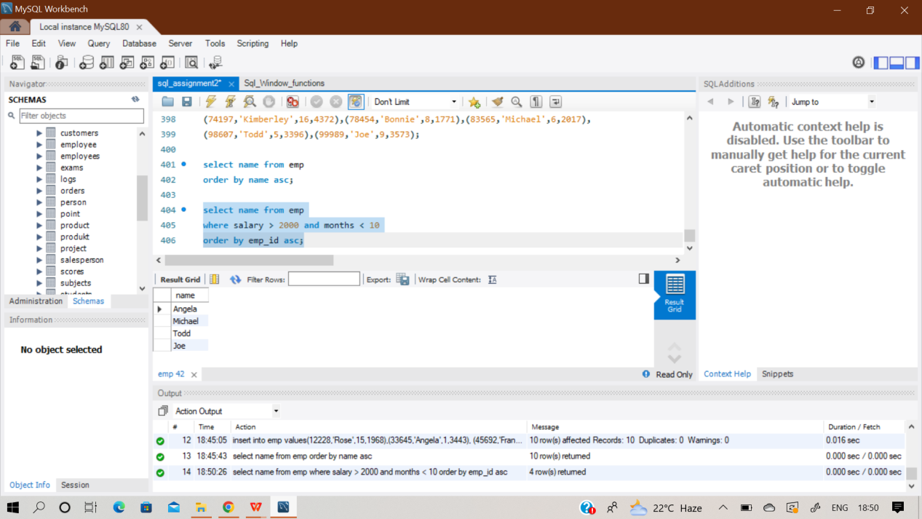

**Q84) Write a query identifying the type of each record in the TRIANGLES table using its three side lengths.**

**Output one of the following statements for each record in the table:**

**● Equilateral: It's a triangle with sides of equal length.**

**● Isosceles: It's a triangle with sides of equal length.**

**● Scalene: It's a triangle with sides of differing lengths.**

**● Not A Triangle: The given values of A, B, and C don't form a triangle.**

Sol) At first create an empty table named ‘Triangles’ and then insert the values in it as per in the question.

**select (case when A=B and B=C then 'Equilateral'**

**when A=B or B=C or A=C then 'Isosceles'**

**when A+B<=C or A+C<=B or B+C<=A then 'Not a Triangle'**

**else 'Scalene'**

**end) as output**

**from triangles;**

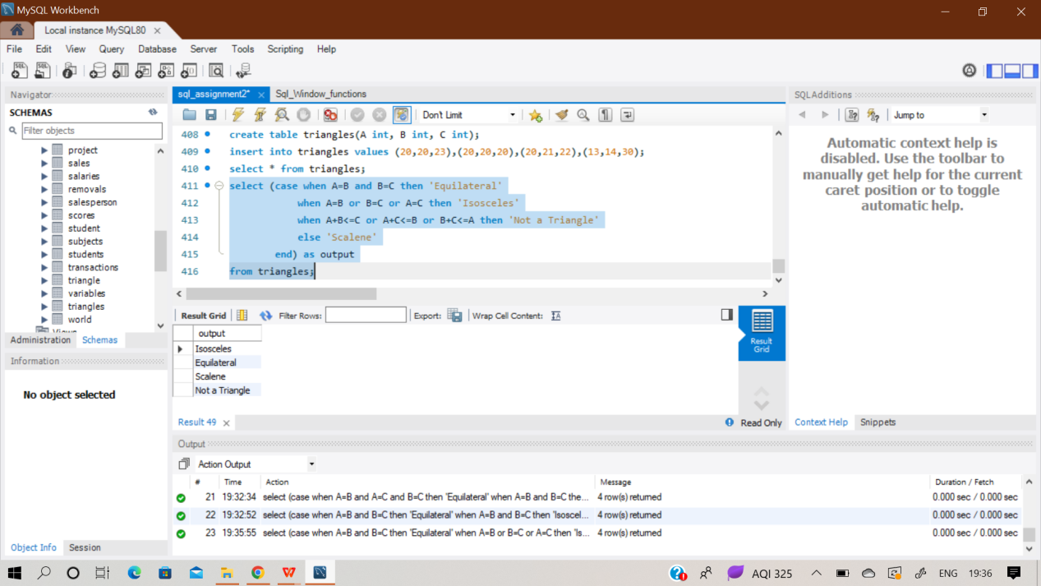

**Q85) Assume you are given the table below containing information on user transactions for particular products. Write a query to obtain the year-on-year growth rate for the total spend of each product for each year.**

**Output the year (in ascending order) partitioned by product id, current year's spend, previous year's spend and year-on-year growth rate (percentage rounded to 2 decimal places).**

Sol) At first create an empty table ‘user_transactions’ and then insert value in it. The values of the transaction date column in the table is not in standard MYSQL format , hence I have converted the 4 values to the standard values using STR_TO_DATE function.

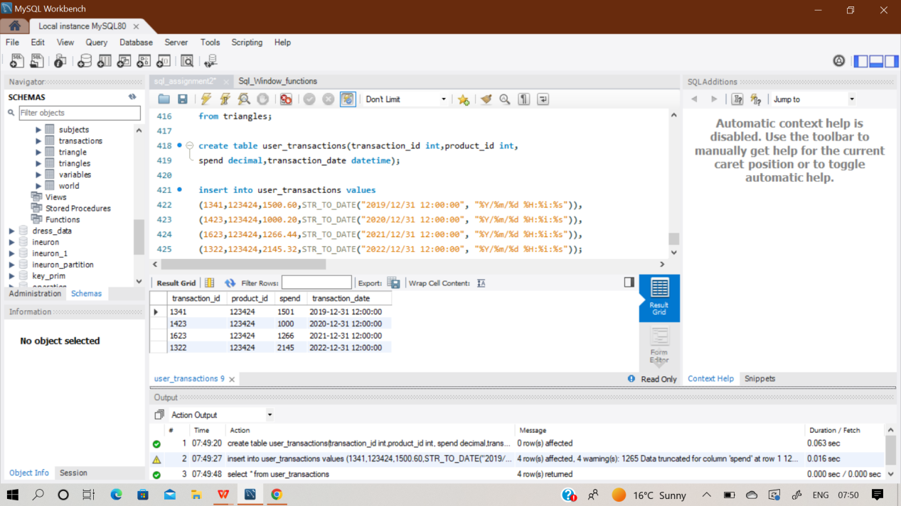

After inserting the values and converting the timestamp datatype to the standard format , the table is ready for analysis purpose. Here in the query, I have extracted the year part from ‘transactio_date’ using extract function And by using 2 common table expressions.

**with cte1 as**

**(select extract(year from transaction_date) as year,**

**product_id,spend as 'curr_year_spend'**

**from user_transactions),**

**cte2 as**

**(select *,lag(curr_year_spend,1) over(partition by product_id order by product_id,year)**

**as 'prev_year_spend' from cte1)**

**select year,product_id,curr_year_spend,prev_year_spend,**

**round(100*(curr_year_spend-prev_year_spend)/prev_year_spend,2) as 'yoy_rate'**

**from cte2;**

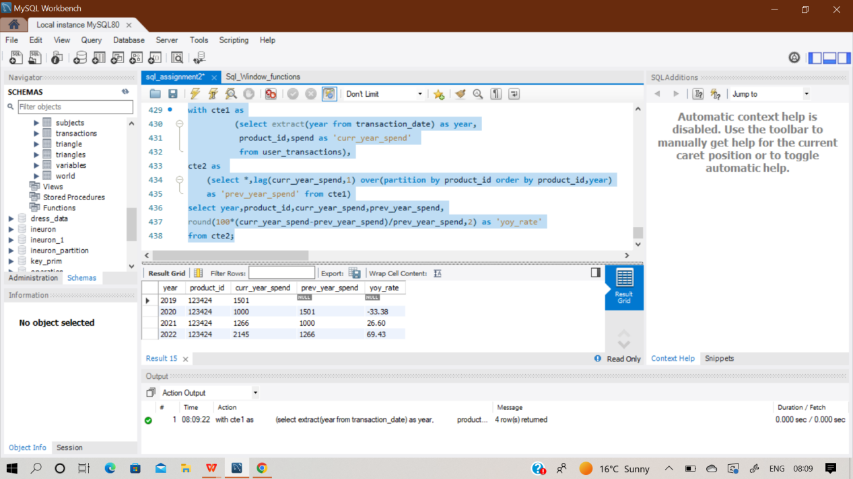

**Q86) Amazon wants to maximize the number of items it can stock in a 500,000 square feet warehouse. It wants to stock as many prime items as possible, and afterwards use the remaining square footage to**

**stock the most number of non-prime items. Write a SQL query to find the number of prime and non-prime items that can be stored in the 500,000 square feet warehouse. Output the item type and number of items to be stocked.**

Sol) At first create an empty table ‘Inventory’ and then insert value in it

Using multi insert statement.

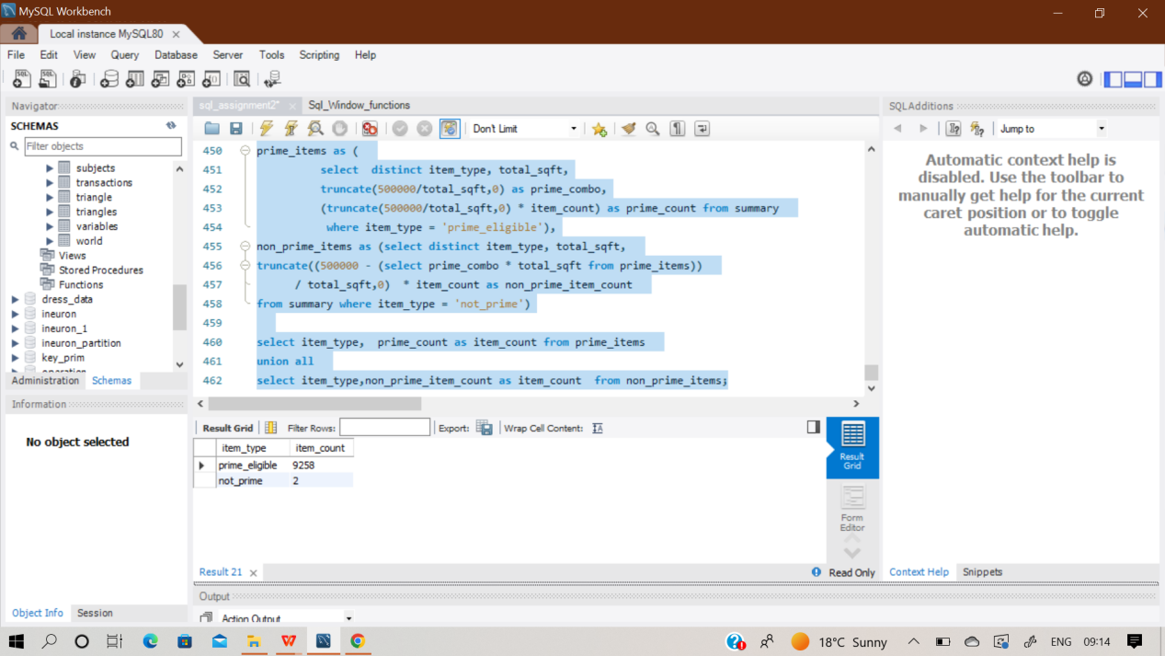

**with summary as (**

**select item_type,sum(square_footage) as total_sqft,count(*) as 'item_count'**

**from inventory group by item_type),**

**prime_items as (**

**select distinct item_type, total_sqft,**

**truncate(500000/total_sqft,0) as prime_combo,**

**(truncate(500000/total_sqft,0) * item_count) as prime_count from summary**

**where item_type = 'prime_eligible'),**

**non_prime_items as (select distinct item_type, total_sqft,**

**truncate((500000 - (select prime_combo * total_sqft from prime_items))**

**/ total_sqft,0) * item_count as non_prime_item_count**

**from summary where item_type = 'not_prime')**

**select item_type, prime_count as item_count from prime_items**

**union all**

**select item_type,non_prime_item_count as item_count from non_prime_items;**

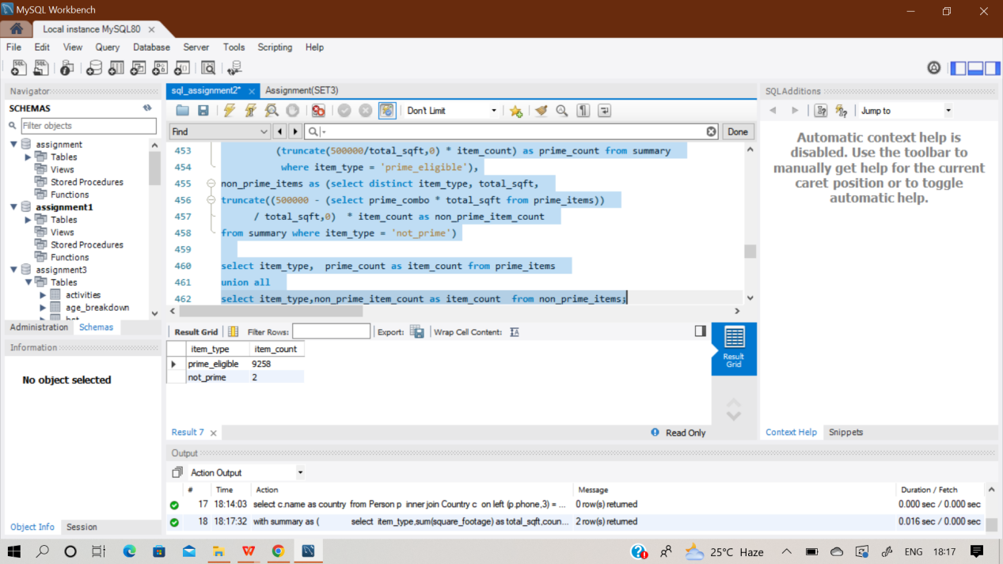

**Q87) Assume you have the table below containing information on Facebook user actions. Write a query to obtain the active user retention in July 2022. Output the month (in numerical format 1, 2, 3) and the number of monthly active users (MAUs).**

Sol) At first create an empty table ‘user_actions’ and then insert value in it. The values of the ‘event date’ column in the table is not in standard MYSQL format , hence I have converted the 5 values to the standard values using STR_TO_DATE function.

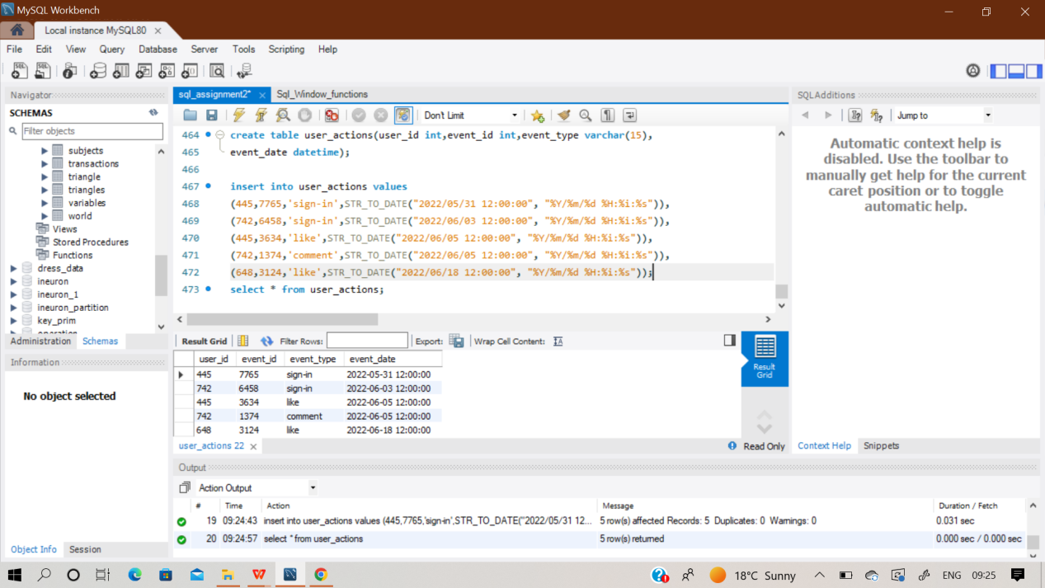

**select**

**extract(month from curr_month.event_date) as mth,**

**count(distinct curr_month.user_id) as monthly_active_users**

**from user_actions as curr_month**

**where exists (**

**select last_month.user_id**

**from user_actions as last_month**

**where last_month.user_id = curr_month.user_id**

**and extract(month from last_month.event_date) =**

**extract(month from curr_month.event_date - interval '1 month')**

**)**

**and extract(month from curr_month.event_date) = 7**

**group by extract(month from curr_month.event_date);**

**Q88) Google's marketing team is making a Superbowl commercial and needs a simple statistic to put on their TV ad: the median number of searches a person made last year. However, at Google scale, querying the 2 trillion searches is too costly. Luckily, you have access to the summary table which tells you the number of searches made last year and how many Google users fall into that bucket.**

**Write a query to report the median of searches made by a user. Round the median to one decimal**

**Sol)** At first create an empty table ‘search’ and then insert value in it

Using multi insert statement.

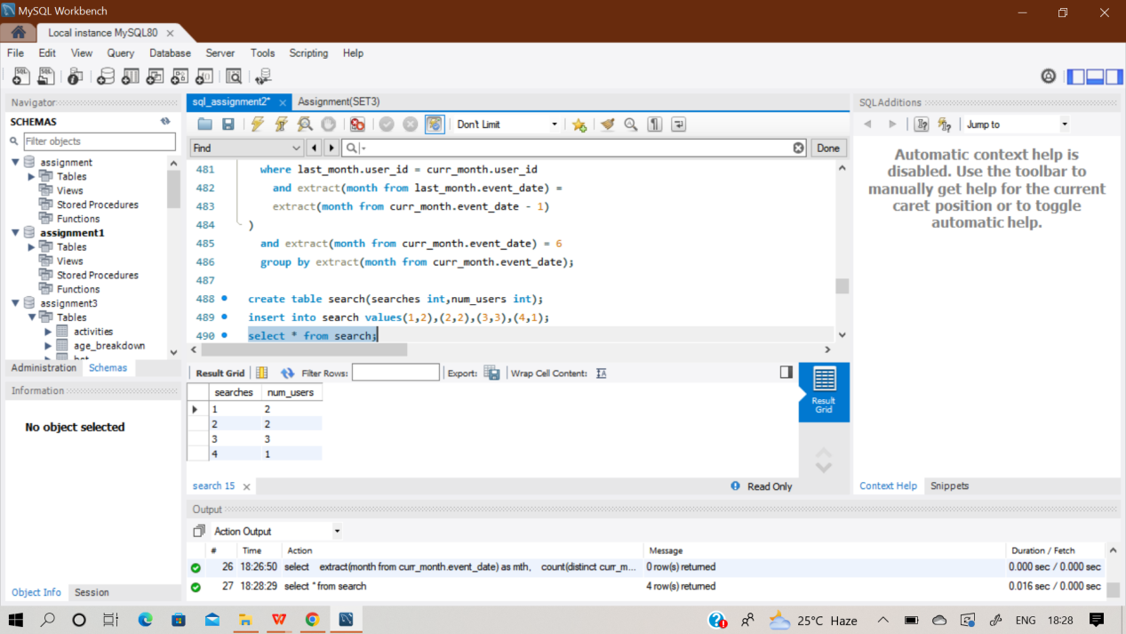

**Q89) Write a query to update the Facebook advertiser's status using the daily_pay table. Advertiser is a two-column table containing the user id and their payment status based on the last payment and**

**daily_pay table has current information about their payment. Only advertisers who paid will show up in this table. Output the user id and current payment status sorted by the user id.**

**Sol)**At first create an empty table ‘advertiser’ & ‘daily_table’ and then insert value in it using multi insert statement.

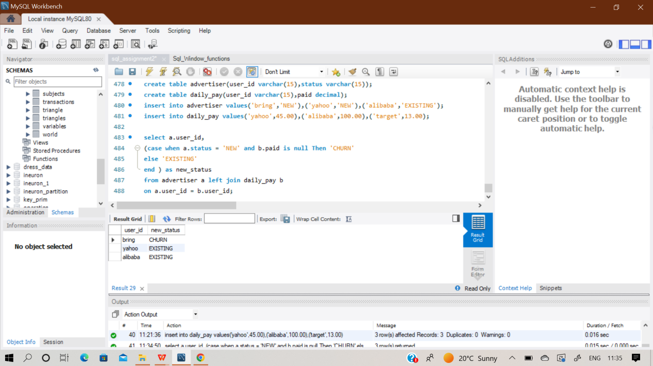

**select a.user_id,**

**(case when a.status = 'NEW' and b.paid is null Then 'CHURN'**

**else 'EXISTING'**

**end ) as new_status**

**from advertiser a left join daily_pay b**

**on a.user_id = b.user_id;**

**Q90) Amazon Web Services (AWS) is powered by fleets of servers. Senior management has requested data-driven solutions to optimize server usage. Write a query that calculates the total time that the fleet of servers was running. The output should be in units of full days.**

**Sol)**At first create an empty table ‘severs’ and then insert value in it using multi insert statement.

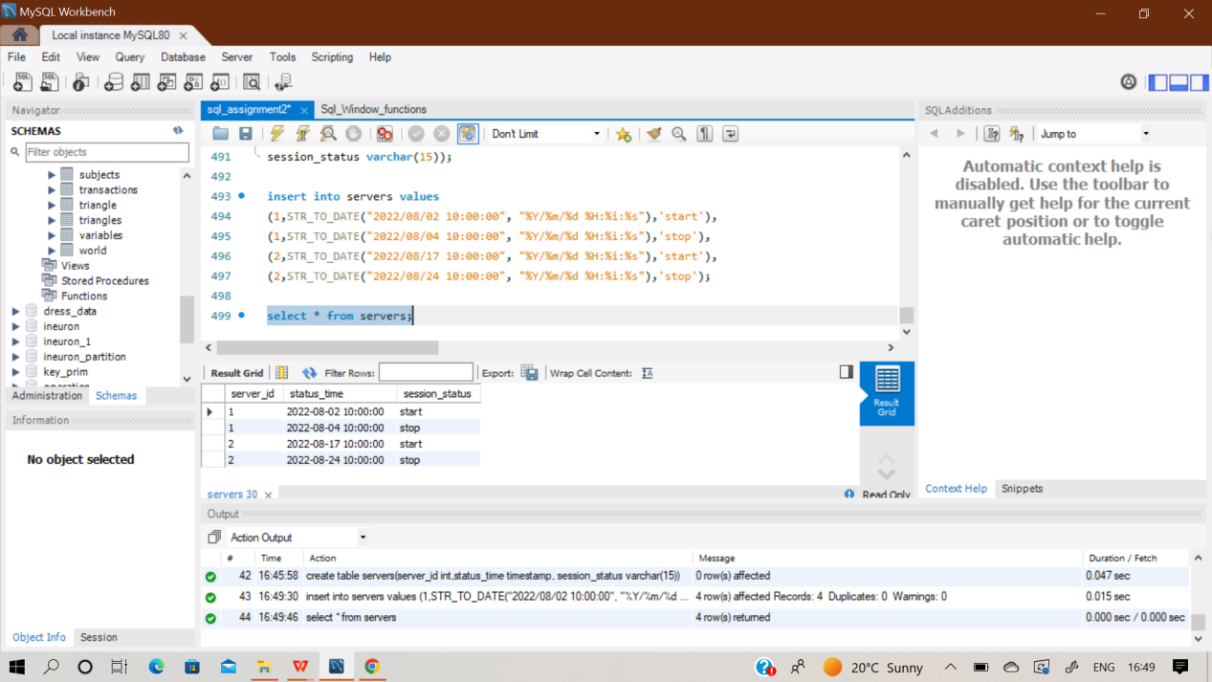

**Q91) Sometimes, payment transactions are repeated by accident; it could be due to user error, API failure or a retry error that causes a credit card to be charged twice. Using the transactions table, identify any payments made at the same merchant with the same credit card for the same amount within 10 minutes of each other. Count such repeated payments.**

Sol) At first create an empty table ‘transactions’ and then insert value in it. The values of the ‘transaction_timestamp’ column in the table is not in standard MYSQL format , hence I have converted the 5 values to the standard values using STR_TO_DATE function.

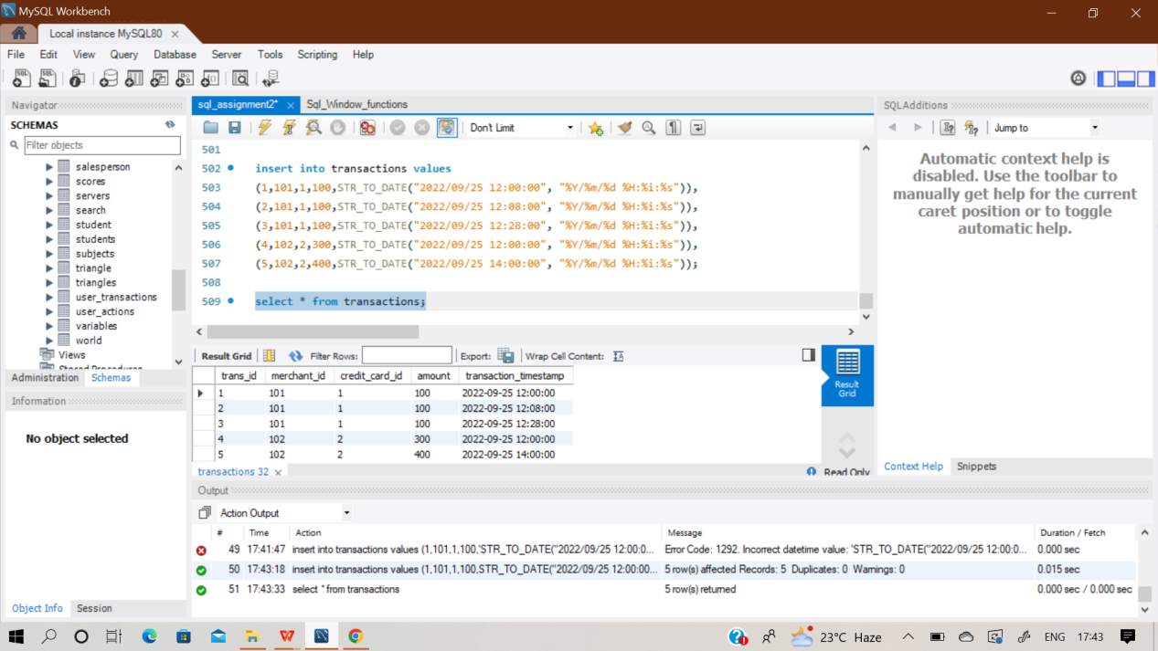

**with payment as**

**(select *,extract(minute from transaction_timestamp - lag(transaction_timestamp)**

**over (partition by merchant_id,credit_card_id,amount order by transaction_timestamp))**

**as 'minute_diff'**

**from transactions)**

**select count(merchant_id) as 'payment_count'**

**from payment**

**where minute_diff<=10;**

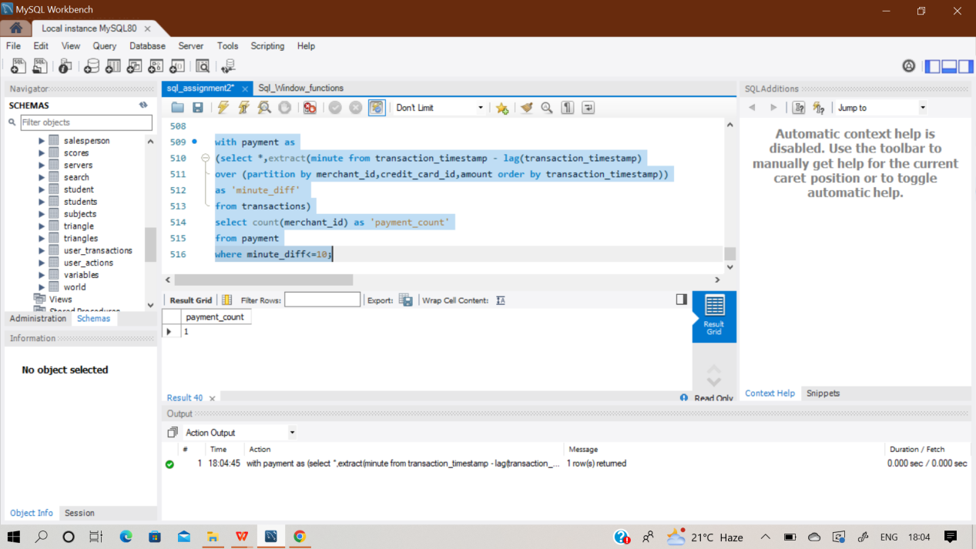

**Q92**)**DoorDash's Growth Team is trying to make sure new users (those who are making orders in their first 14 days) have a great experience on all their orders in their 2 weeks on the platform. Unfortunately, many deliveries are being messed up because:**

**● the orders are being completed incorrectly (missing items, wrong order, etc.)**

**● the orders aren't being received (wrong address, wrong drop off spot)**

**● the orders are being delivered late (the actual delivery time is 30 minutes later than when the**

**order was placed).**

**Write a query to find the bad experience rate in the first 14 days for new users who signed up in June**

**2022. Output the percentage of bad experience rounded to 2 decimal places.**

**Sol)**At first create an empty table ‘orders’,’trips’ & ‘customers’ and then insert value in it using multi insert statement.

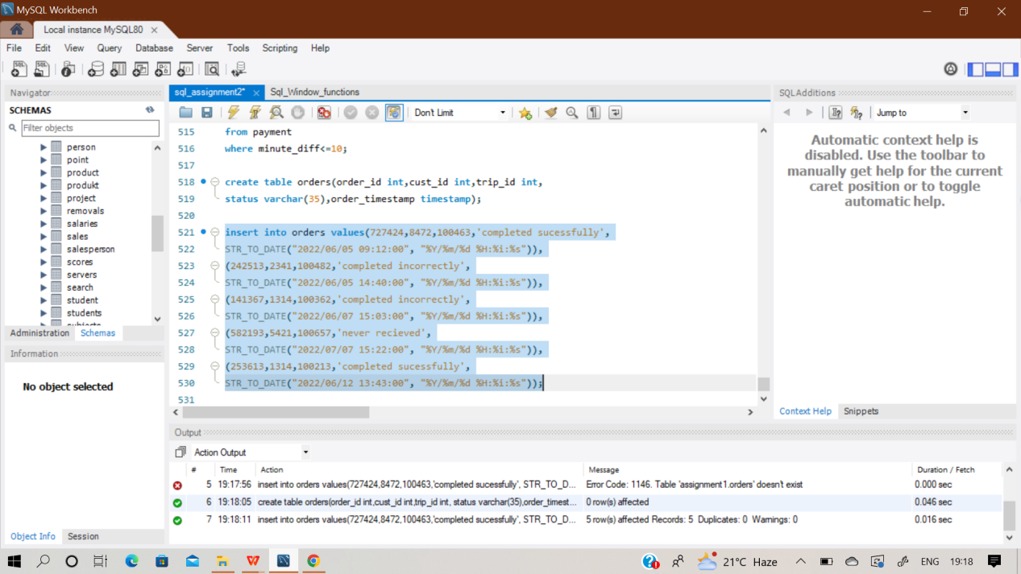

**with cte as(**

**select o.order_id,o.trip_id,o.status**

**from customers c join orders o**

**on c.cust_id =o.cust_id where extract(month from c.signup_timestamp) = 6**

**and extract(year from c.signup_timestamp) = 2022)**

**select round(100.0*count(summary.order_id)/**

**(select count(order_id) from cte),2) as bad_experience_pct**

**from cte as summary**

**join trips t on summary.trip_id = t.trip_id**

**where summary.status not in ('completed successfully') or**

**t.actual_delivery is null and**

**t.estimated_delivery > t.actual_delivery;**

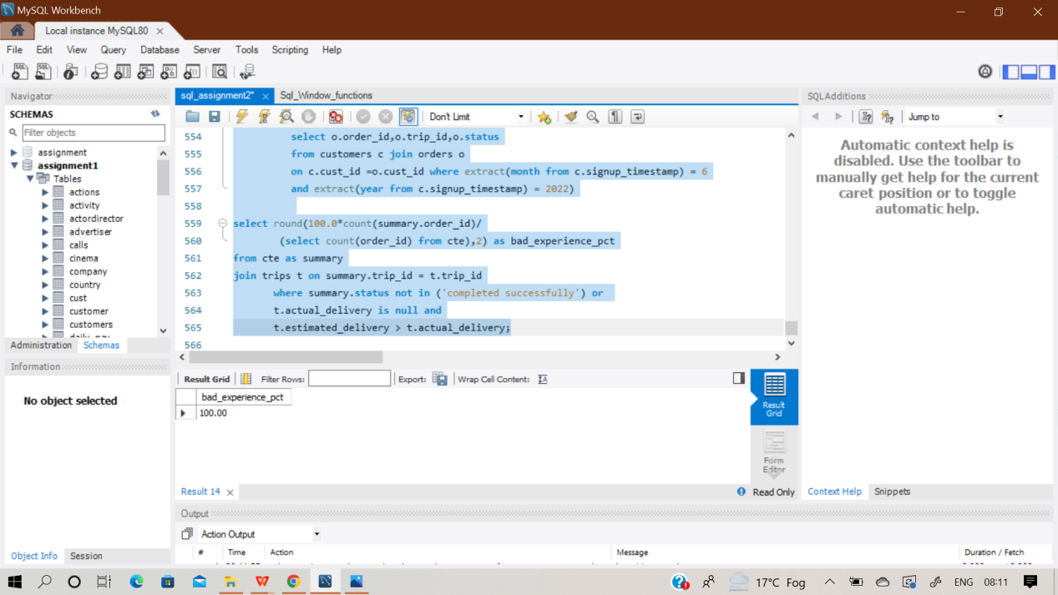

**Q93) SAME QUESTION AS Q68**

**Q94) SAME QUESTION AS Q55**

**Q95)Write an SQL query to report the median of all the numbers in the database after decompressing the Numbers table. Round the median to one decimal point. The query result format is in the following example.**

**Sol)**At first create an empty table ‘Numbers’ and then insert value in it using multi insert statement.

**Q96) Write an SQL query to report the comparison result (higher/lower/same) of the average salary of employees in a department to the company's average salary. Return the result table in any order. The query result format is in the following example**

Sol) At first create two empty tables ‘salary ’ and ‘employee’ and then insert records in it using multi insert function.

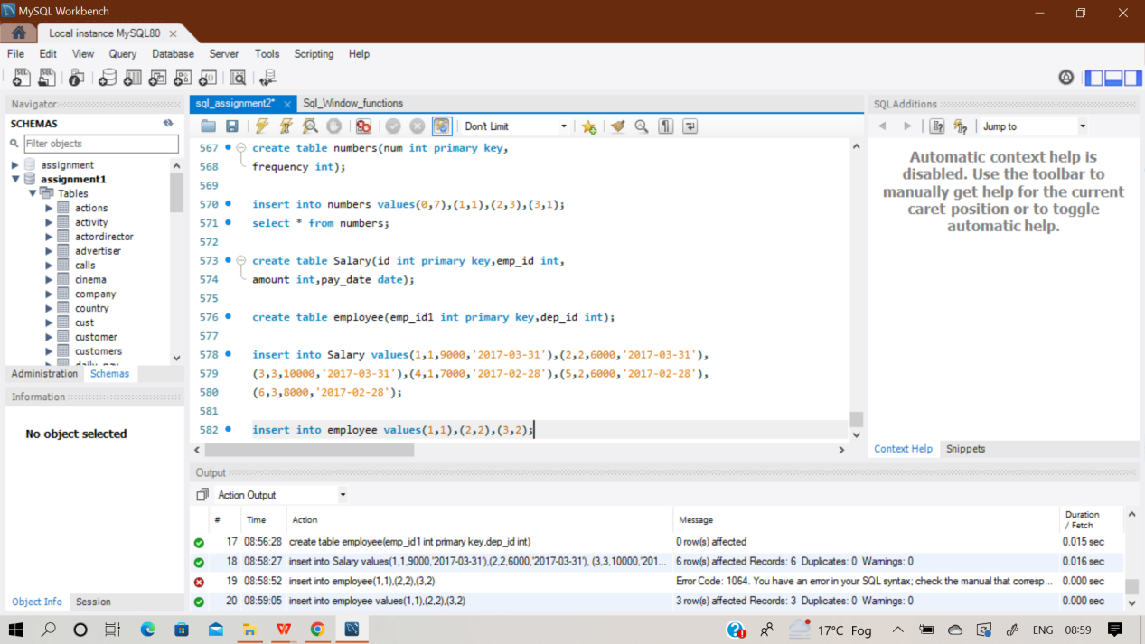

**select pay_month,dep_id,**

**(case when dept_avg > comp_avg then 'higher' when dept_avg < comp_avg then 'lower'**

**else 'same'**

**end) as comparison**

**from (**

**select date_format(b.pay_date, '%Y-%m') pay_month,**

**a.dep_id, avg(b.amount) dept_avg, d.comp_avg**

**from employee a inner join salary b**

**on (a.emp_id1 = b.emp_id)**

**inner join (select date_format(c.pay_date, '%Y-%m') pay_month, avg(c.amount) comp_avg**

**from salary c group by date_format(c.pay_date, '%Y-%m')) d**

**on ( date_format(b.pay_date, '%Y-%m') = d.pay_month)**

**group by date_format(b.pay_date, '%Y-%m'), dep_id, d.comp_avg) final;**

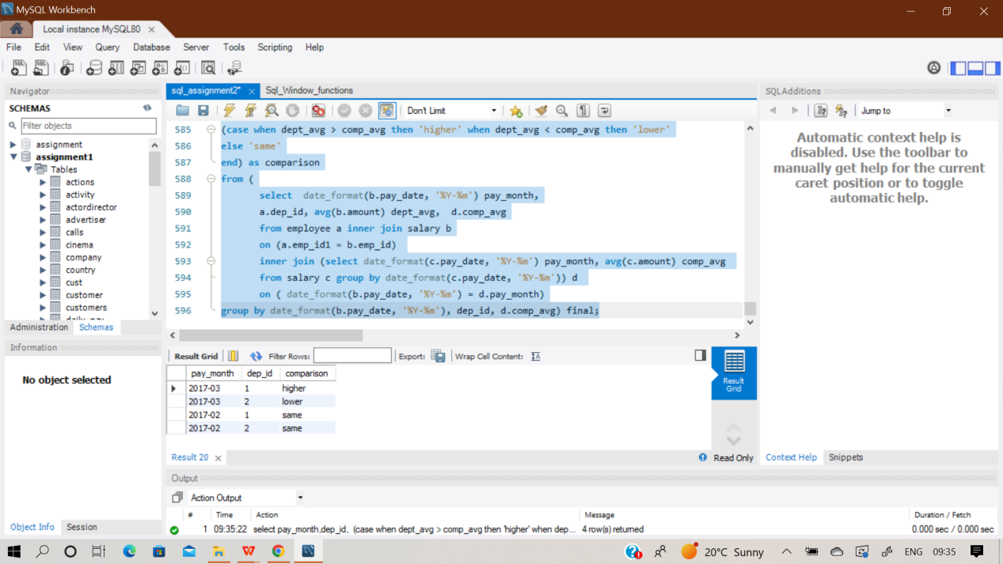

**Q97) Write an SQL query to report for each install date, the number of players that installed the game on that day, and the day one retention. Return the result table in any order. The query result format is in the following example.**

Sol) The table used for this question is already created and ready for analysis purpose.

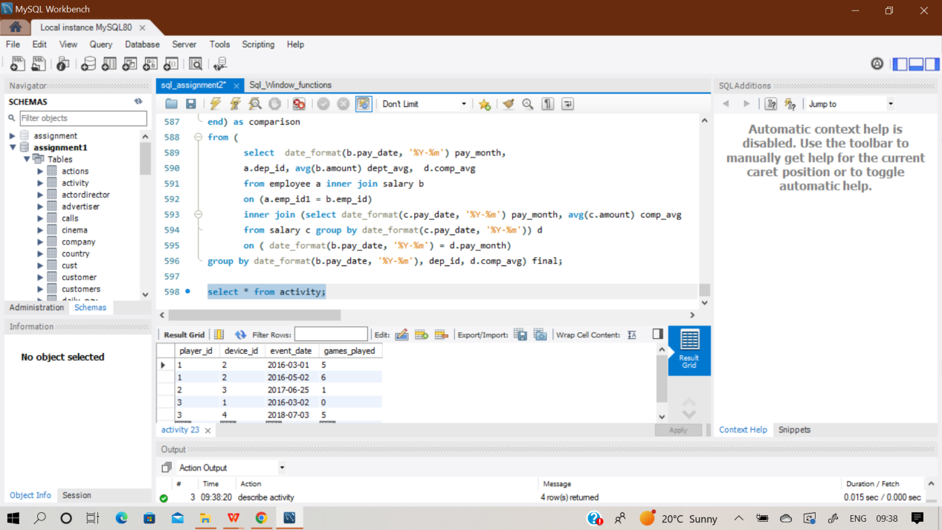

**select a.event_date as install_dt, count(a.player_id) as installs,**

**round(count(b.player_id)/count(a.player_id), 2) as Day1_retention**

**from (select player_id, MIN(event_date) as event_date from activity**

**group by player_id) a**

**left join activity b on a.player_id = b.player_id and a.event_date + 1=b.event_date**

**group by a.event_date;**

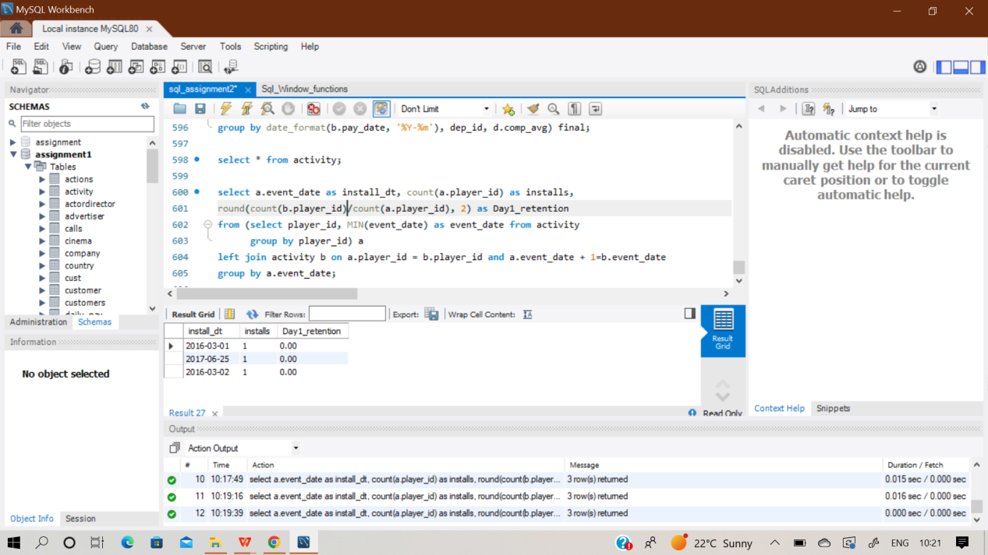

**Q98) SAME QUESTION AS Q50**

**Q99) Write an SQL query to report the students (student_id, student_name) being quiet in all exams. Do not return the student who has never taken any exam.Return the result table ordered by student_id. The query result format is in the following example.**

Sol) At first create two empty tables ‘student ’ and ‘exam’ and then insert records in it using multi insert function.

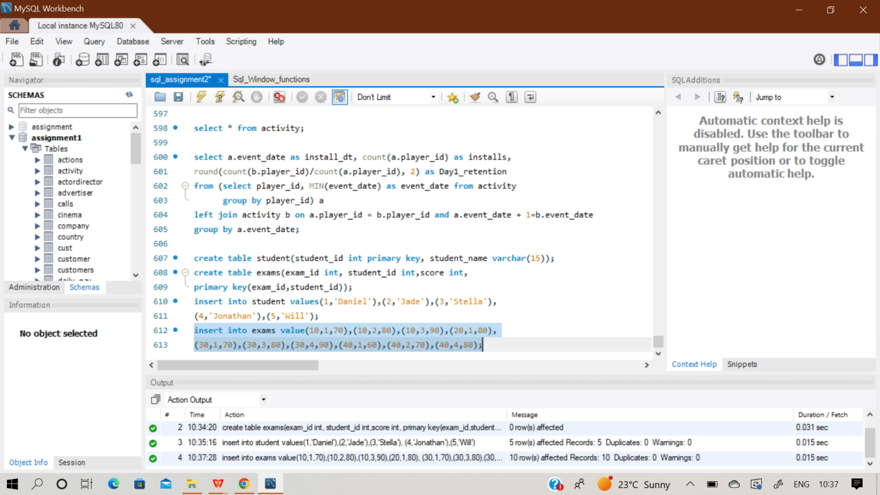

**select s.student_id, s.student_name from student s inner join**

**(select a.student_id,count(a.exam_id) as total_exam,**

**sum(case when a.score > min_score and a.score < max_score then 1**

**else 0 end)as quite_exam**

**from exams a**

**inner join (select exam_id, min(score) as min_score,max(score) as max_score**

**from exams group by exam_id order by null) b**

**on a.exam_id = b.exam_id**

**group by a.student_id**

**order by null) c**

**on s.student_id = c.student_id**

**where c.total_exam = c.quite_exam**

**order by s.student_id;**

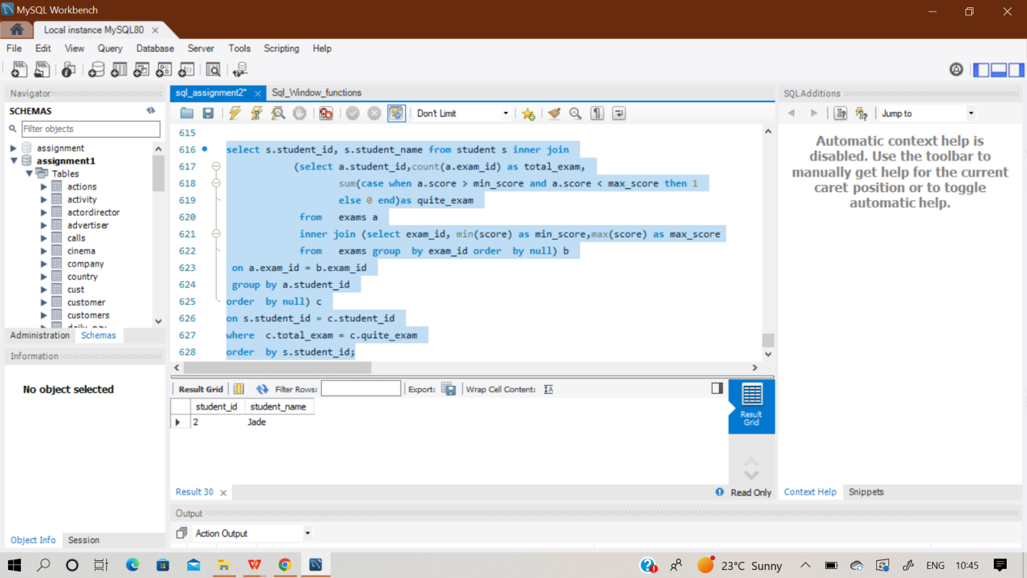

**Q100) SAME QUESTION AS Q99**